Neon models audit
2026-10-26 · Godot city

Summary
The library holds 18 neon models in 16 files, and only 8 are drawn on the map today, once each (8 uses in total).
- 1 pack file (neon_vegas.glb) holds 3 models (CLUB, GIRL, LOVE), all unused.
- 15 split files hold 1 model each: 8 used once, 7 unused.
- New since the first audit: the bold club signs (CLUB, XXX, OPEN, PRIVE, LIVE) and the heart. Three of them stand on Las Vegas office roofs; BOLD and PRIVE found no office at their spot.
- Uses are counted on the generated map (buildings carrying the neon as a wall or roof sign), not from the code constants.
- Previews are the renders from docs/model_previews_neon and docs/model_previews_vegas. Procedural neon textures (sign atlas) are not counted.

Model | Category | Source file | Uses
vegas_club | NEON_CLUB | neon_vegas.glb (node vegas_club) | 0
vegas_girl | NEON_GIRL | neon_vegas.glb (node vegas_girl) | 0
vegas_love | NEON_LOVE | neon_vegas.glb (node vegas_love) | 0
neon_club_xxx | NEON_CLUB_XXX | neon_club_xxx.glb | 1
neon_club_open | NEON_CLUB_OPEN | neon_club_open.glb | 1
neon_club_live | NEON_CLUB_LIVE | neon_club_live.glb | 1
neon_heart | NEON_HEART | neon_heart.glb | 1
neon_pacman | NEON_PACMAN | neon_pacman.glb | 1
neon_fun | NEON_FUN | neon_fun.glb | 1
neon_palm | NEON_PALM | neon_palm.glb | 1
neon_martini | NEON_MARTINI | neon_martini.glb | 1
neon_club_bold | NEON_CLUB_BOLD | neon_club_bold.glb | 0
neon_club_prive | NEON_CLUB_PRIVE | neon_club_prive.glb | 0
neon_woman | NEON_WOMAN | neon_woman.glb | 0
neon_controller | NEON_CONTROLLER | neon_controller.glb | 0
neon_joystick | NEON_JOYSTICK | neon_joystick.glb | 0
neon_bar | NEON_BAR | neon_bar.glb | 0
neon_bull | NEON_BULL | neon_bull.glb | 0

Neon packs
One pack, neon_vegas.glb, holds three club roof signs. They are set for three Las Vegas clubs (map_retouch.gd), but Las Vegas lost its clubs, so none of them is on the map.

vegas_club (NEON_CLUB) · 0 uses
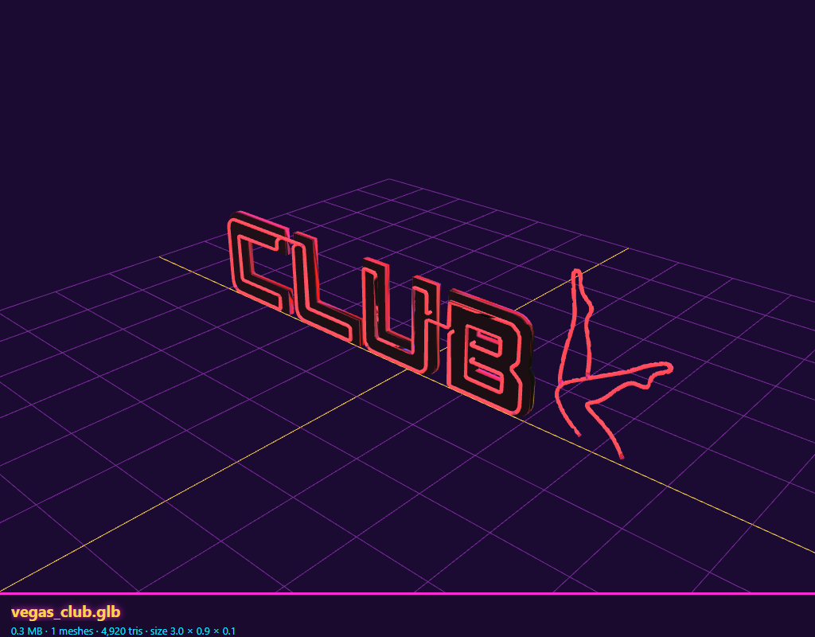

vegas_girl (NEON_GIRL) · 0 uses
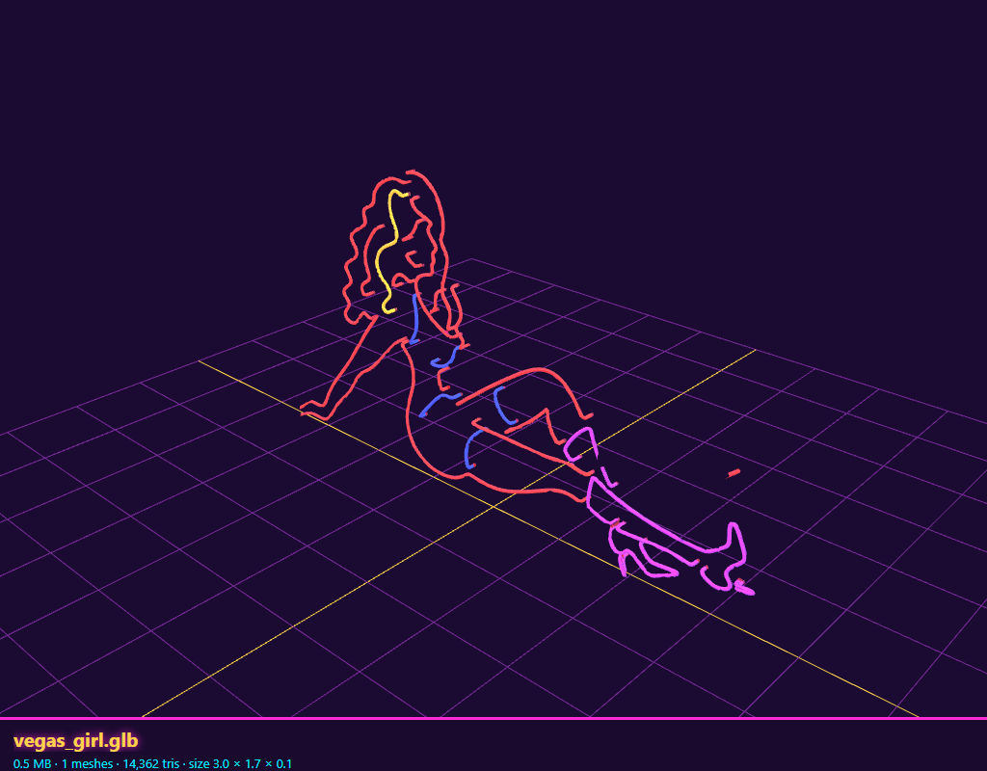

vegas_love (NEON_LOVE) · 0 uses
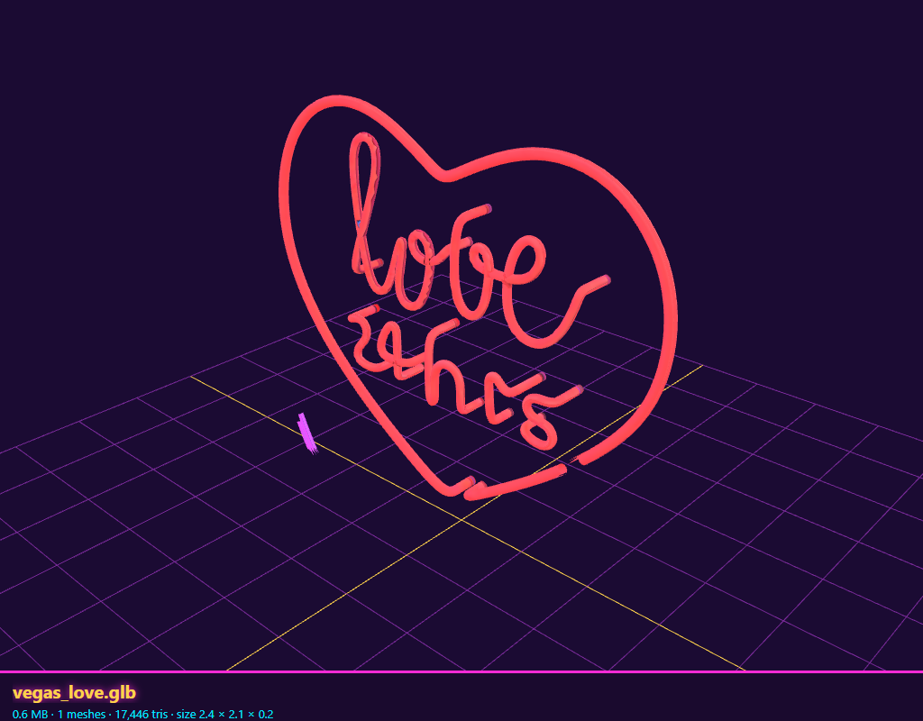

Split neon models, on the map
Eight single-model files, each drawn once.

neon_club_xxx (NEON_CLUB_XXX) · 1 use
Roof of a Las Vegas office.
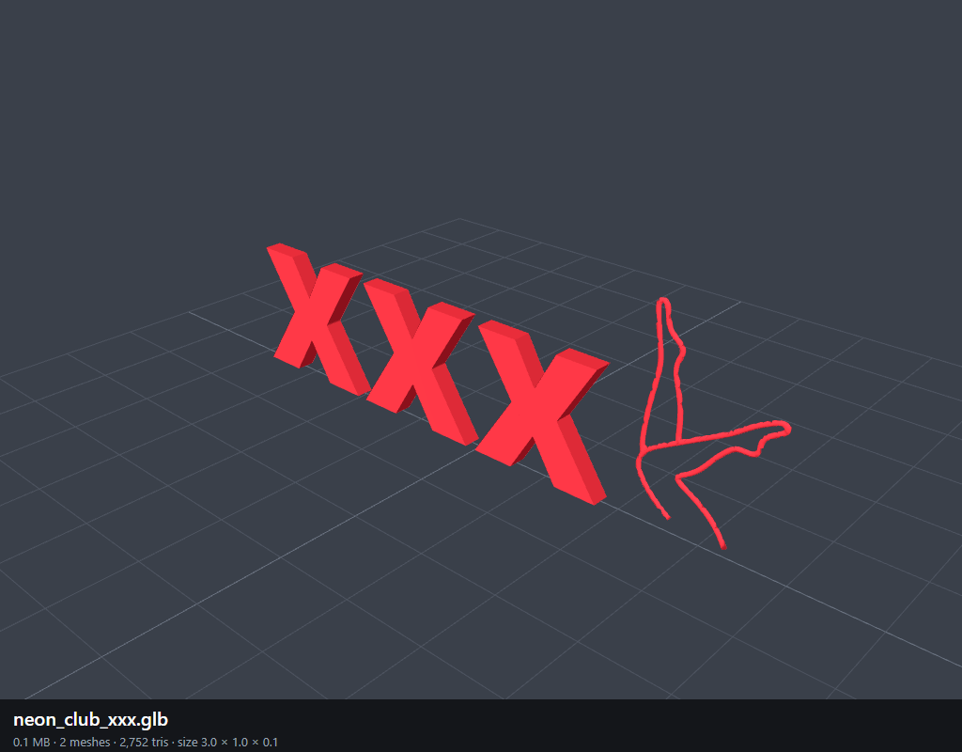

neon_club_open (NEON_CLUB_OPEN) · 1 use
Roof of a Las Vegas office.
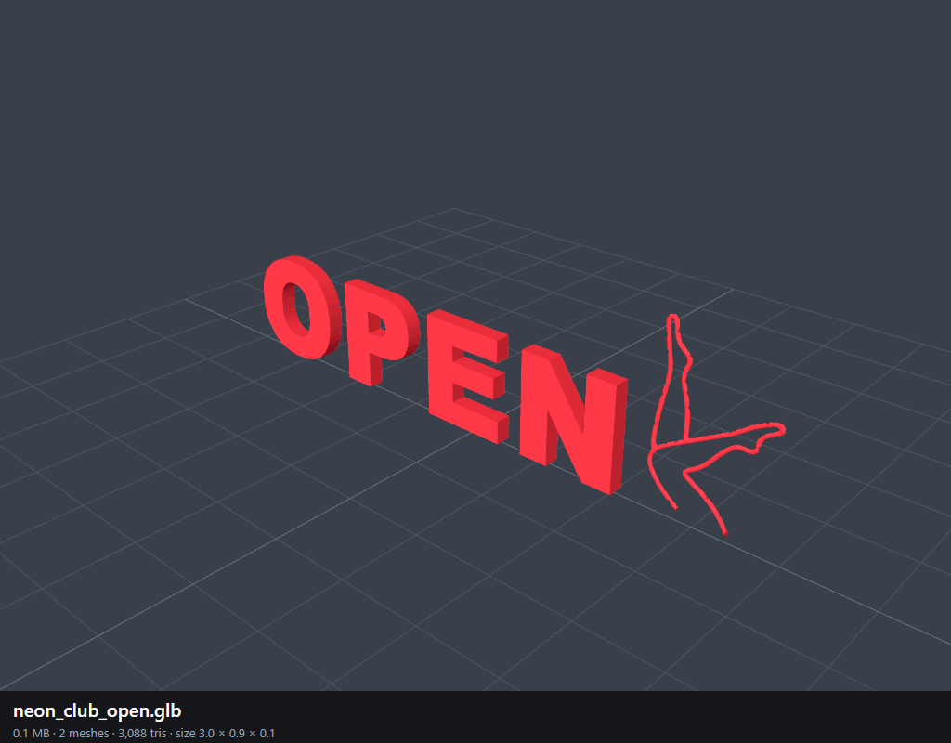

neon_club_live (NEON_CLUB_LIVE) · 1 use
Roof of a Las Vegas office.
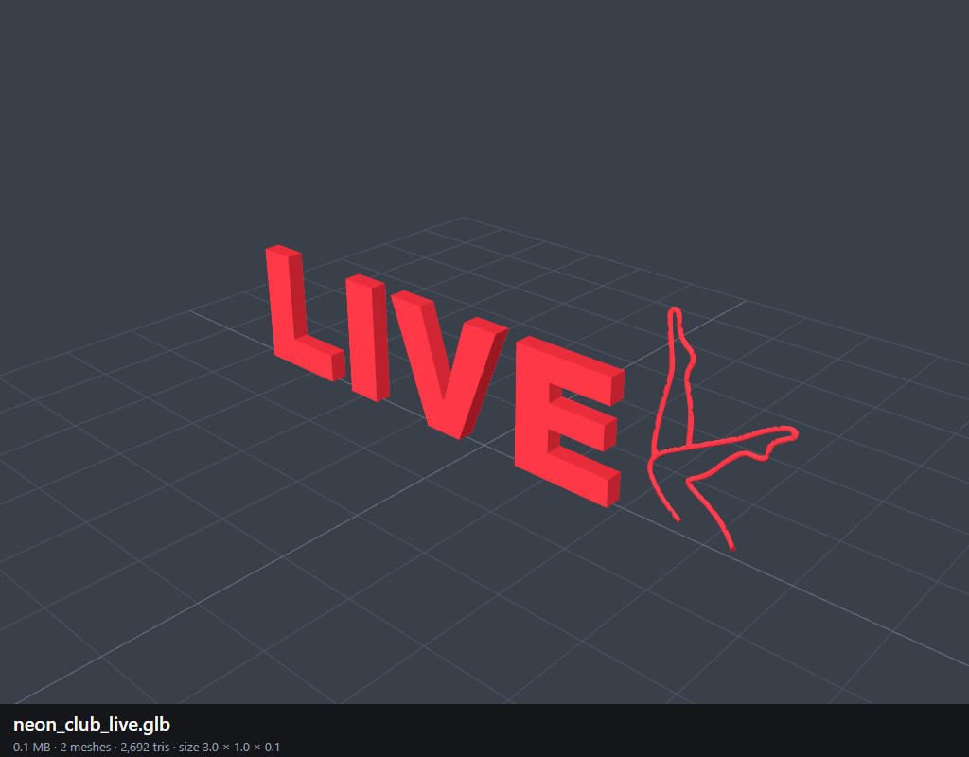

neon_heart (NEON_HEART) · 1 use
Roof of a Las Vegas office.
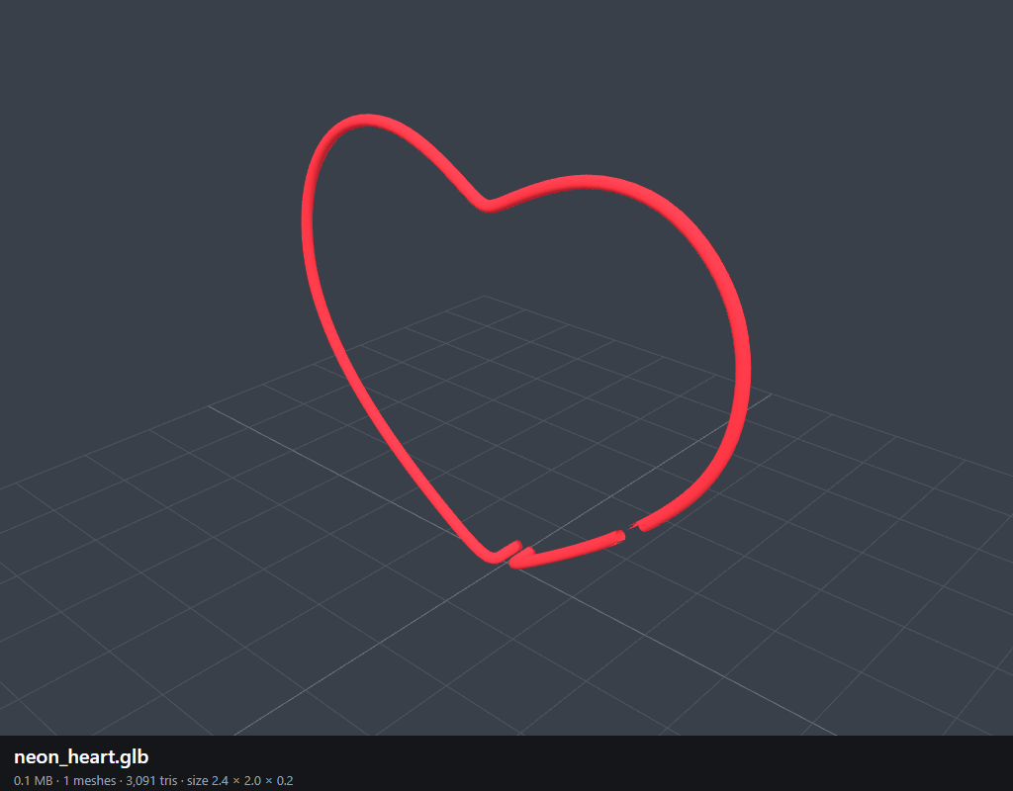

neon_pacman (NEON_PACMAN) · 1 use
Roof of a skyline tower, moved by map_changes.gd.
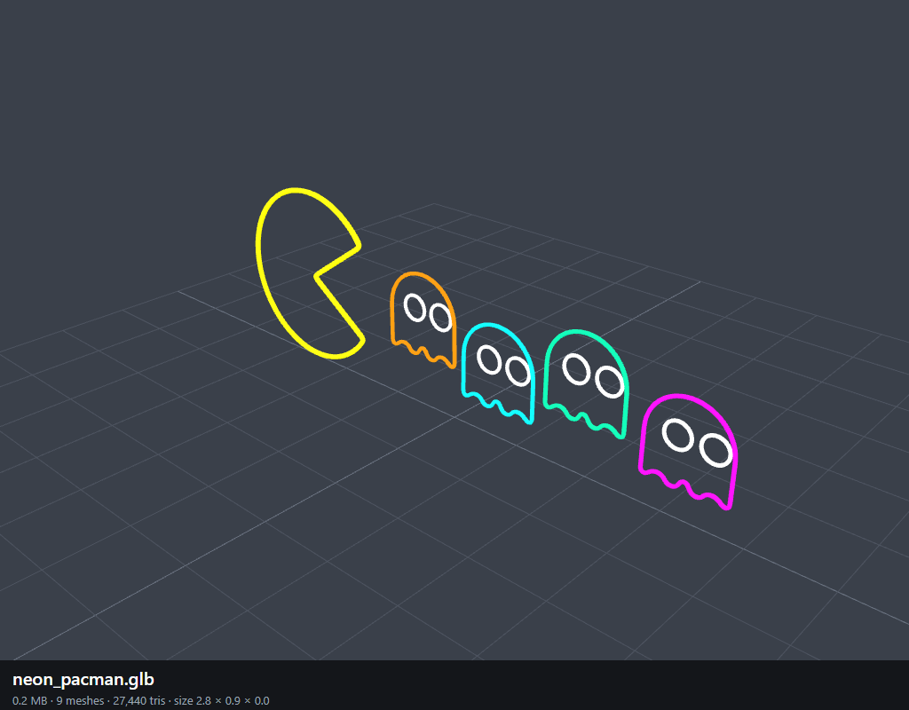

neon_fun (NEON_FUN) · 1 use
Wall of an urban island tower.
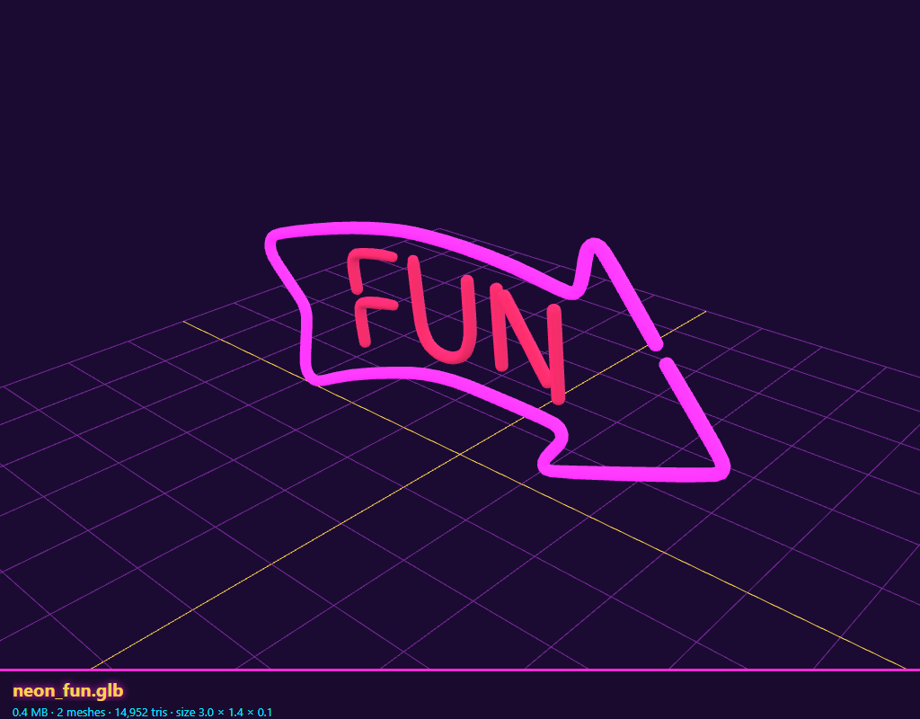

neon_palm (NEON_PALM) · 1 use
Wall of an urban island tower.
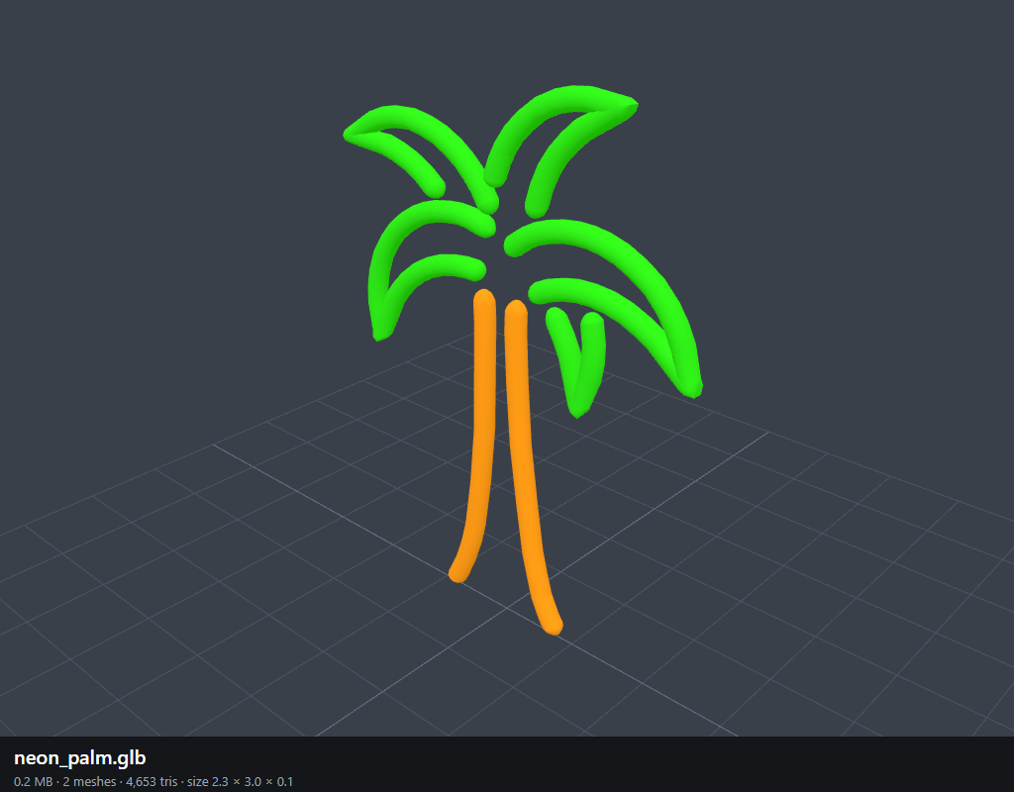

neon_martini (NEON_MARTINI) · 1 use
Second sign on a tower roof.
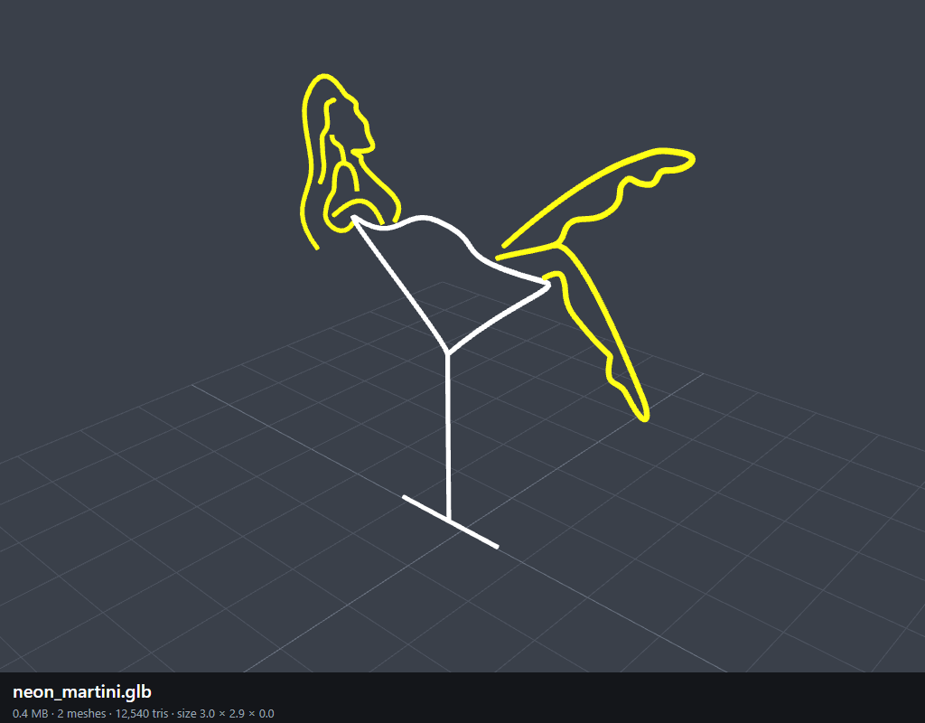

Split neon models, not on the map
Seven single-model files, drawn nowhere.

neon_club_bold (NEON_CLUB_BOLD) · 0 uses
The generator finds no Las Vegas office at its spot (137, 178).
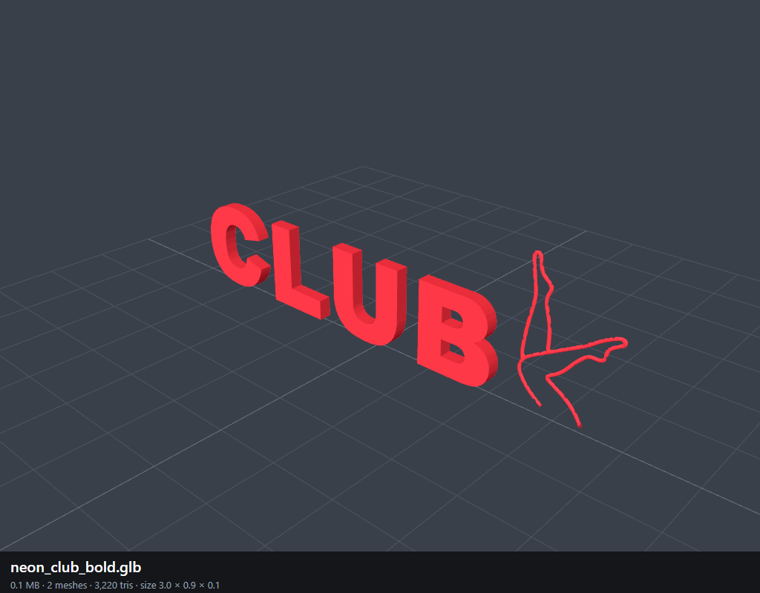

neon_club_prive (NEON_CLUB_PRIVE) · 0 uses
The generator finds no Las Vegas office at its spot (147, 181).
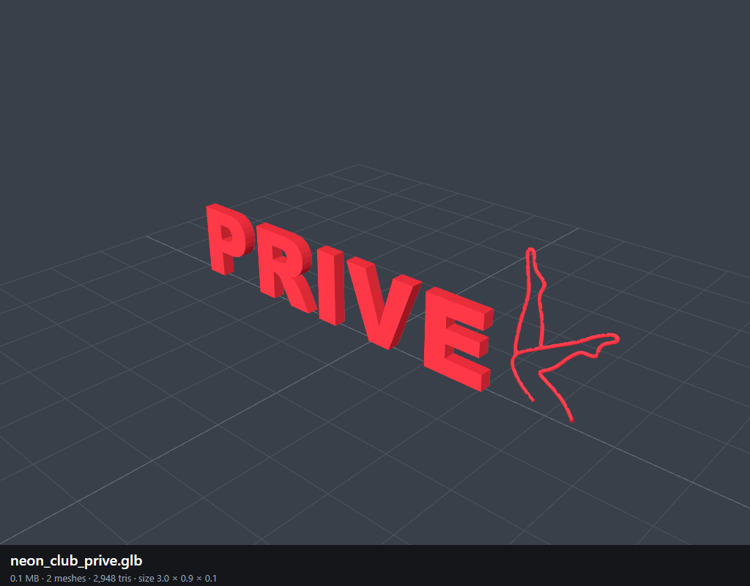

neon_woman (NEON_WOMAN) · 0 uses
It stood on the Las Vegas neon tower; the latest building deletions removed a neon skyscraper.
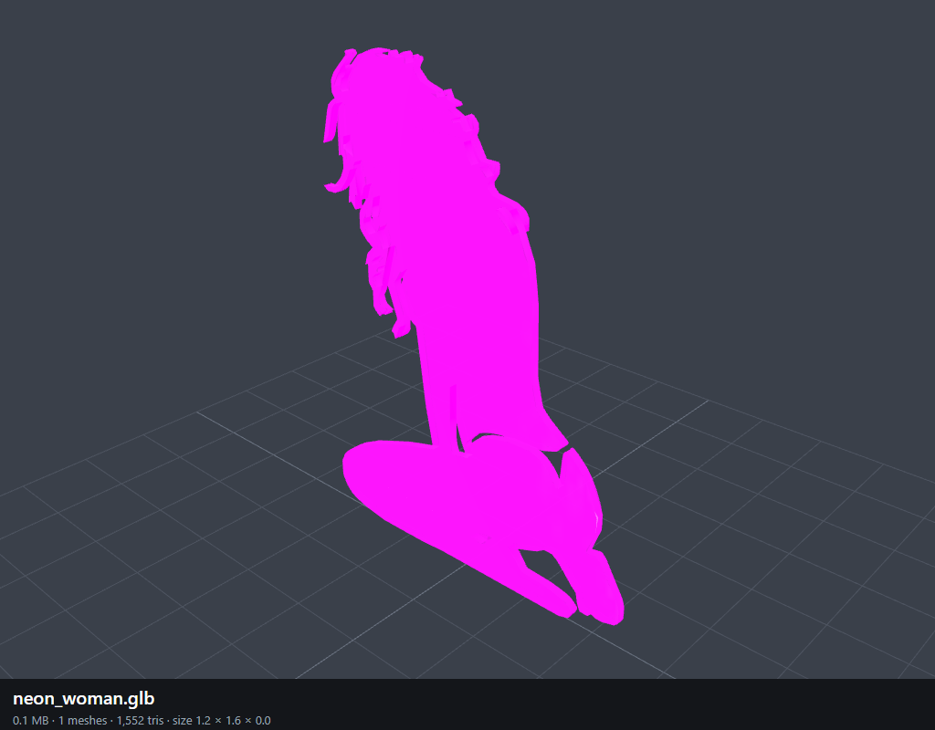

neon_controller (NEON_CONTROLLER) · 0 uses
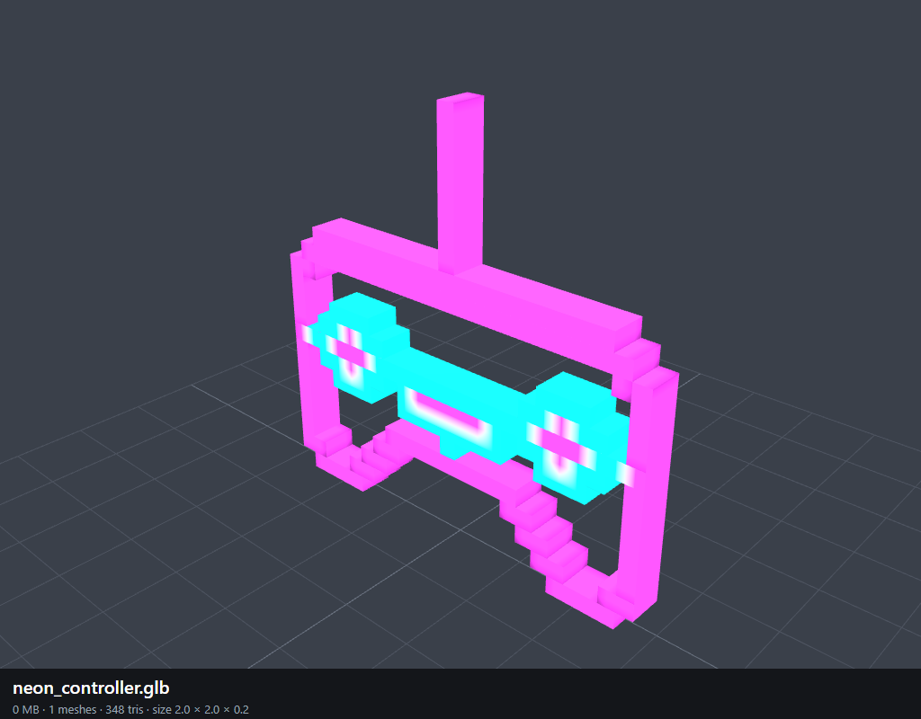

neon_joystick (NEON_JOYSTICK) · 0 uses
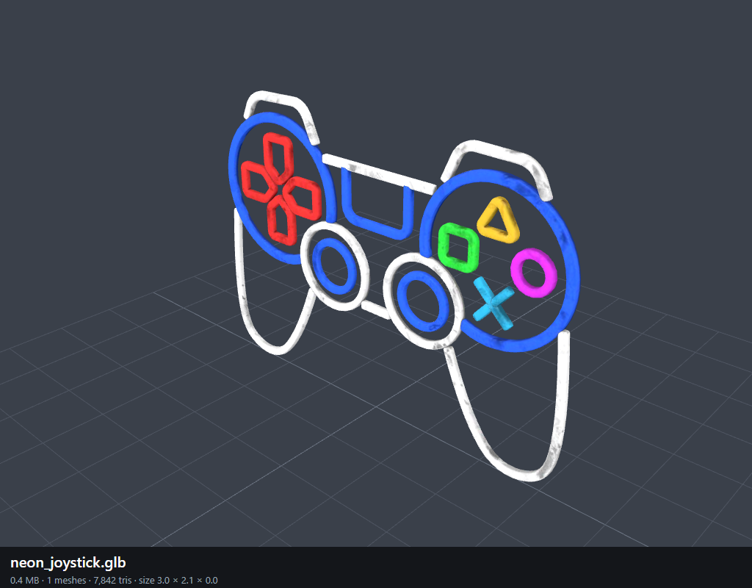

neon_bar (NEON_BAR) · 0 uses
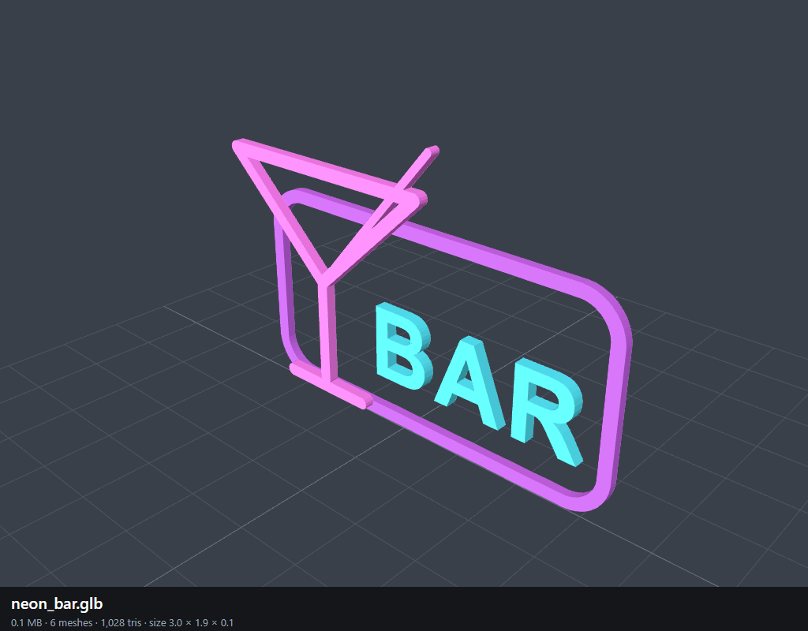

neon_bull (NEON_BULL) · 0 uses
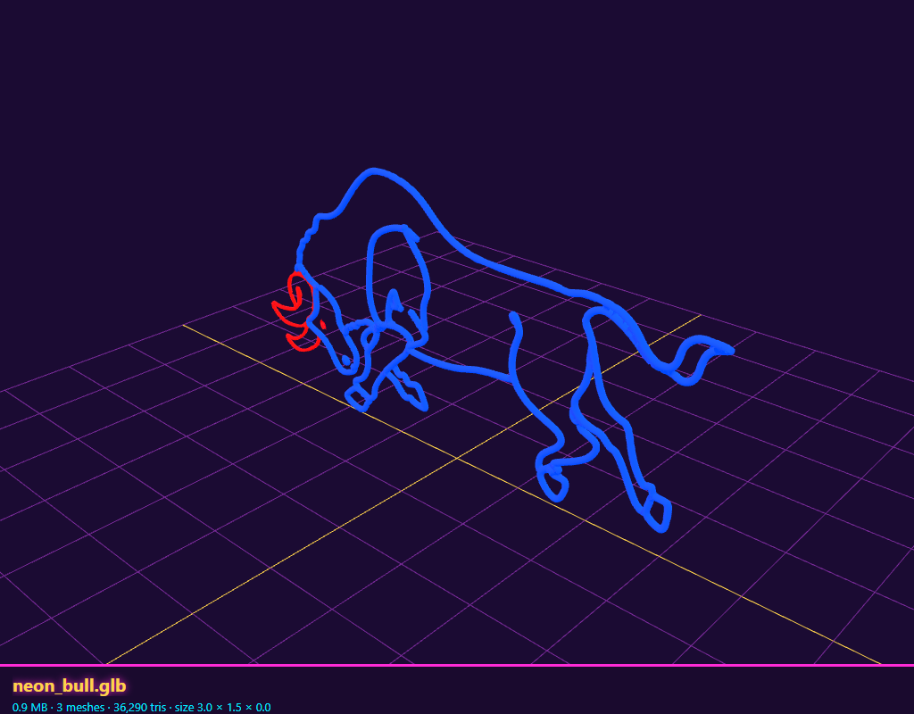

Chat City Boulevard wall neons
2026-10-28 · Chat City (ChatCityApp public/models/neons)
Studio Boutique offers 86 wall neons: the eight curated Godot neons above (love, club-xxx, club-live, heart, palm, martini, woman, bar) and these 78, traced from neon sign photos into round glass tubes by ChatCityApp's scripts/boulevard-models/neonPhotos.py. A seller picks one; it hangs on both side walls of their shop (or where the shop's layout puts it), dim by day and lit at night.
22 from the photo folder "NEON sexy".
56 from the photo folder "more Neon sexy".
Lettering drawn from a font instead of the photo: live-sex, send-nudes, adults-only.
3.9 MB in all; each file loads only when a shop shows it or Studio Boutique draws its card.
Neon | Label | Colours | Triangles | KB | Photo
lady-seated | Seated lady | magenta | 6,912 | 46 | NEON sexy / 01_9b12cd4d-d996-4788-949a-fb0883524cfe.webp
legs-frame | Legs in heels | blue | 7,184 | 46 | NEON sexy / 01bf1de17b9cbfdd857ed247a7ddb927.jpg
leg-ring-gold | Golden leg | yellow | 4,384 | 29 | NEON sexy / 23WomanLegs_yellow_1800x1800.webp
bikini-body | Bikini | magenta | 6,736 | 44 | NEON sexy / 65369ac06e351d7b9358ae8d-lady-neon-signs-female-body-curves-neon.jpg
hands-hips | Hands | cyan, pink | 10,400 | 68 | NEON sexy / 719pRQA8nRL.jpg
back-curves | Curves | pink | 3,424 | 23 | NEON sexy / 71cSEQD4sTL._AC_UF1000,1000_QL80_.jpg
pin-up | Pin-up | cyan, magenta | 4,912 | 34 | NEON sexy / 761b6034e413b377b0515cba25dda2e63397edff73138f07aaea5eac426e593e.webp
leg-ring-violet | Violet leg | purple | 4,960 | 33 | NEON sexy / 81XF1uT2IfL._AC_SL1500_.jpg
lips-strawberry | Strawberry lips | green, magenta, pink, red, white | 13,008 | 88 | NEON sexy / Glowneon-Sexy-Lips-Neon-Sign-Sexy-Mouth-Led-Sign-Strawberry-Neon-5.jpeg
heels-crossed | Crossed legs | orange, white | 4,496 | 31 | NEON sexy / Legs 512.jpg
bad-girl | Bad girl | pink | 7,344 | 48 | NEON sexy / Sexy_Bad_Girl_Middle_Finger_LED_Neon_Sign_bd5d5415.webp
biting-lip | Biting lip | magenta, pink, white | 6,256 | 43 | NEON sexy / biting-lip-neon-sign-sexy-neon-light-bedroom-neon-sign-297783.webp
leggings | Leggings | purple, white | 3,488 | 24 | NEON sexy / il_300x300.4878921754_qedo.webp
bikini-pose | Bikini pose | magenta | 6,240 | 41 | NEON sexy / il_570xN.4756069899_slnc.webp
shh | Shh | magenta, white, yellow | 5,616 | 39 | NEON sexy / images (1).jfif
high-heels-open | High heels open | green, red, yellow | 12,528 | 82 | NEON sexy / images (1).png
stockings | Stockings | pink, red | 6,416 | 43 | NEON sexy / images (2).jfif
reclining | Reclining | magenta | 6,688 | 44 | NEON sexy / images (3).jfif
silhouette | Silhouette | magenta | 7,360 | 48 | NEON sexy / images.jfif
stiletto | Stiletto | red | 2,256 | 16 | NEON sexy / images.png
high-heels | High heels | red, white, yellow | 10,784 | 69 | NEON sexy / n105-12003-yellow-high-heels-with-logo-neon-sign.jpg
grab | Grab | magenta | 6,336 | 42 | NEON sexy / non-femmes-sexy-logo-led-usb.webp
standing-woman | Standing woman | orange | 6,336 | 41 | more Neon sexy / 055ea839dbf33d81924b65855c345630_200aa18851271cece323c153c6e26638.avif
flamingo | Flamingo | pink | 3,232 | 22 | more Neon sexy / 103570e595b1300a9ded42476605cba6.jpg
white-legs | White legs | white | 3,104 | 21 | more Neon sexy / 1X8MNK2150.webp
pin-up-colour | Colour pin-up | blue, magenta, orange, pink, purple, red, white | 9,696 | 69 | more Neon sexy / 510c7d06d5994a87bed66abc7a27fe23.jpg
bikini-white | White bikini | blue, magenta, purple, white | 7,536 | 53 | more Neon sexy / 51snQgGS3lL.jpg
lips-tongue | Tongue | magenta, pink, purple, red | 7,248 | 51 | more Neon sexy / 64e67d0391b0af4870384077-nosun-lips-tongue-neon-sign-red-lips.jpg
yellow-lady | Yellow lady | magenta, orange, pink, yellow | 8,704 | 60 | more Neon sexy / 6930958a-7244-42a4-b27d-8e5179fba561.jpg
cowgirl | Cowgirl | magenta, orange, pink, yellow | 8,880 | 61 | more Neon sexy / 6930958a-7244-42a4-b27d-8e5179fba561.jpg
legs-heels | Legs & heels | magenta, pink | 5,872 | 40 | more Neon sexy / 6930958a-7244-42a4-b27d-8e5179fba561.jpg
smoking-hand | Smoke | blue, magenta, purple | 6,704 | 46 | more Neon sexy / 71LX0cTetAL._AC_UL450_SY450_QL70_.jpg
wine-lady | Wine lady | magenta | 6,224 | 41 | more Neon sexy / 71Upj74bQwL.webp
bow | Bow | pink | 4,048 | 27 | more Neon sexy / 81R-vKZwhwL._AC_UL495_SR435,495_.jpg
flame | Flame | orange, red, yellow | 3,056 | 23 | more Neon sexy / 81VrnT4fZQL._AC_UL450_SY450_QL70_.jpg
back-amber | Amber back | orange | 4,336 | 29 | more Neon sexy / He4dd4a02ee2347a9948dfdc38fb9faa0l.webp
tied-legs | Tied legs | blue, cyan, magenta, purple | 9,104 | 62 | more Neon sexy / Hea401391fbbd4312b70502e97ef00620j.avif
back-hat | Hat | magenta, pink, white | 6,960 | 47 | more Neon sexy / Lady+Neon+Signs+Neon+Signs+For+Wall+Decor+Pink+White+LED+Light+Sign+For+Preppy+Room+Decor+Light+Up+Sign+For+Birthday+Party+Decoration+USB+Powered.webp
selfie | Selfie | magenta, red, white | 14,480 | 95 | more Neon sexy / Neon-Femme-Bikini-GTA-300x300.png
live-sex | Live Sex | pink | 6,272 | 41 | more Neon sexy / S71d298adb6f64bb896e45294306c5dd5Z.avif
framed-finger | Framed | blue, magenta, purple | 12,704 | 83 | more Neon sexy / S835cce23af2a44ed9ec2c48d7c3a5cd5v.webp
pole-dance | Dance | magenta, white | 7,488 | 50 | more Neon sexy / Sabed75abb3454c4199dd0fb0ac8ebf47G.png_480x480.png_.avif
send-nudes | Send nudes | blue, magenta, pink, red | 8,032 | 55 | more Neon sexy / Send-Nudes-Neon-Sign-Body-Neon-Woman-Sign-Led-Light-red-wm_1080x.webp
burlesque | Burlesque | orange, red, yellow | 10,832 | 72 | more Neon sexy / Waterproof-Sexy-Women-Figure-Pattern-Personalization-Wall-Sign-LED-Neon-Sign-Custom-Neon.avif
boots | Boots | magenta, purple | 3,664 | 26 | more Neon sexy / c3c5f360-4cc7-45c2-aa6c-1c82059c953e.webp
sunglasses | Sunglasses | cyan, magenta, orange, pink, red, white, yellow | 8,128 | 59 | more Neon sexy / c5a1d058-f13a-4c67-9bc9-af731cb01155.jpg
adults-only | Adults only | orange, pink | 6,528 | 43 | more Neon sexy / d13aa9939a9941518a10b23c65602a8c~tplv-fhlh96nyum-resize-webp_800_800.webp
anime-bikini | Manga bikini | blue, cyan, magenta, purple | 17,120 | 113 | more Neon sexy / ersetze_das_neonschild_202604111024.avif
banana | Banana | cyan, yellow | 3,456 | 25 | more Neon sexy / il_1080xN.6302698191_9qv7.avif
bust | Bust | red | 3,200 | 22 | more Neon sexy / il_300x300.6151516614_guuj.webp
lounging | Lounging | pink | 4,448 | 30 | more Neon sexy / il_300x300.6460533399_fww6.jpg
hug-knees | Knees | blue, cyan, magenta, pink, purple, red | 7,648 | 55 | more Neon sexy / il_300x300.7519725935_mkje.webp
embrace | Embrace | magenta, pink, purple | 8,624 | 58 | more Neon sexy / il_300x300.7947440500_dbhu.avif
angel-wings | Angel wings | white | 18,144 | 116 | more Neon sexy / il_300x300.8011763505_t3uw.webp
wine-glass-lady | In the glass | orange, pink, red, yellow | 6,336 | 45 | more Neon sexy / il_300x300.8044227614_5lja.webp
pole-upside | Upside down | blue, cyan, magenta, pink, purple | 10,992 | 75 | more Neon sexy / il_300x300.8312941256_f2s0.avif
towel | Towel | magenta, pink, white | 5,120 | 36 | more Neon sexy / il_fullxfull.6813833290_tn9q.avif
mudflap | Mudflap | pink | 3,200 | 22 | more Neon sexy / images (1).jfif
lollipop-lips | Lollipop | magenta, orange, pink, red, yellow | 5,696 | 42 | more Neon sexy / images (10).jfif
garter-legs | Garters | blue, pink, purple, red | 8,784 | 61 | more Neon sexy / images (11).jfif
legs-up | Legs up | pink | 6,144 | 41 | more Neon sexy / images (2).jfif
bar-bottle | Bar bottle | cyan, magenta, orange, pink, red, white, yellow | 10,288 | 72 | more Neon sexy / images (3).jfif
bar-lady | Bar lady | blue, green, magenta, pink, purple, white | 10,032 | 69 | more Neon sexy / images (4).jfif
cheers | Cheers | red | 5,152 | 35 | more Neon sexy / images (5).jfif
cocktail | Cocktail | orange, white, yellow | 6,464 | 44 | more Neon sexy / images (6).jfif
moon-girl | Moon girl | magenta, pink | 8,304 | 55 | more Neon sexy / images (7).jfif
relax | Relax | cyan, green | 7,568 | 50 | more Neon sexy / images (9).jfif
curvy-silhouette | Curvy | magenta | 4,400 | 29 | more Neon sexy / images.jfif
bikini-girl | Bikini girl | blue, cyan, magenta, pink, red, white | 15,440 | 104 | more Neon sexy / jessica-bunny-neon-led-schild.webp
kiss-me | Kiss me | cyan, orange, pink, red, white, yellow | 6,864 | 51 | more Neon sexy / kiss-me-neon-sign-pink_1000x.webp
sexy | Sexy | magenta | 7,472 | 48 | more Neon sexy / neon-sign-bright-colors-girls-260nw-1333214828.webp
legs-gold | Gold legs | yellow | 3,936 | 27 | more Neon sexy / neon-sign-showing-woman-legs-in-sexy-pose-on-black-background-vector.jpg
legs-red | Red legs | red | 2,800 | 19 | more Neon sexy / night-club-led-led-neon-light-line-women-leg-led-neon-lamp-sexy-aesthetic-png.webp
bum-outline | Outline | magenta | 2,448 | 17 | more Neon sexy / nude-neon-lamp.jpg
pole-girl | Pole girl | blue, cyan, magenta, pink, purple, white | 12,800 | 87 | more Neon sexy / s-l1200.png
anime-heart | Manga heart | blue, cyan, purple, white | 20,000 | 131 | more Neon sexy / sarah-love-bunny-neon-led-schild.webp
bikini-standing | Pink bikini | orange, pink, red | 7,920 | 53 | more Neon sexy / siluette-neon-led-schild.webp
anime-sitting | Manga sitting | purple, white | 17,376 | 112 | more Neon sexy / tanja-bunny-neon-led-schild.webp

lady-seated (Seated lady)
magenta; 6,912 triangles; 46 KB; 2.47 x 3.07 m as built (the shop scales it to its wall). Photo: NEON sexy / 01_9b12cd4d-d996-4788-949a-fb0883524cfe.webp.
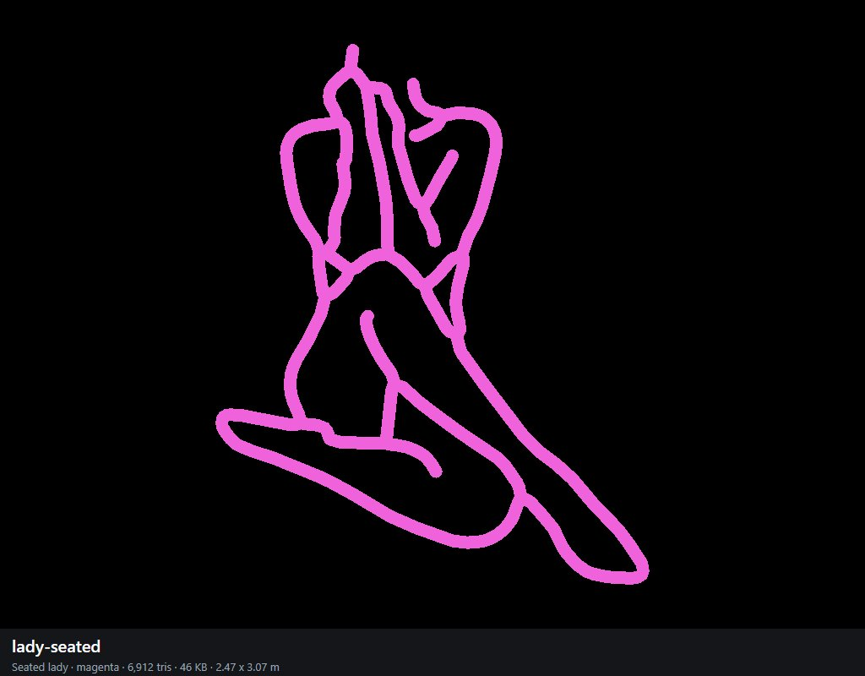

legs-frame (Legs in heels)
blue; 7,184 triangles; 46 KB; 1.48 x 3.06 m as built (the shop scales it to its wall). Photo: NEON sexy / 01bf1de17b9cbfdd857ed247a7ddb927.jpg.
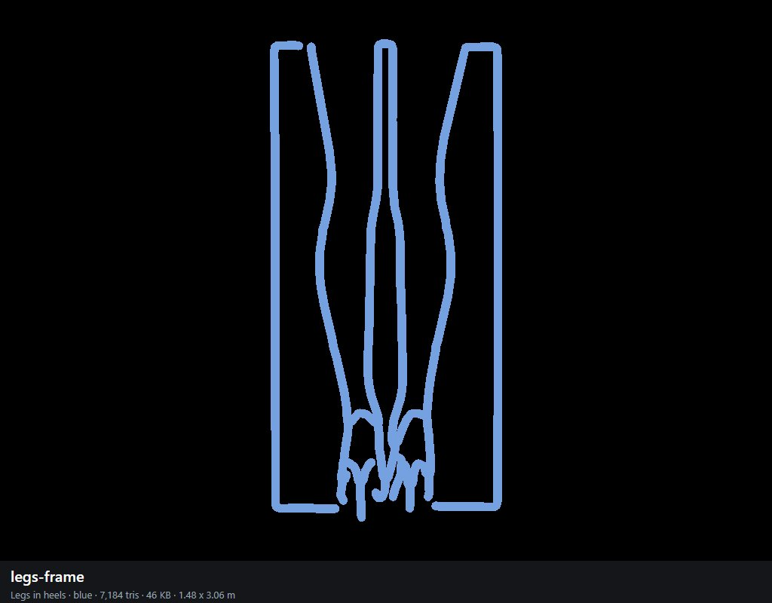

leg-ring-gold (Golden leg)
yellow; 4,384 triangles; 29 KB; 1.28 x 3.06 m as built (the shop scales it to its wall). Photo: NEON sexy / 23WomanLegs_yellow_1800x1800.webp.
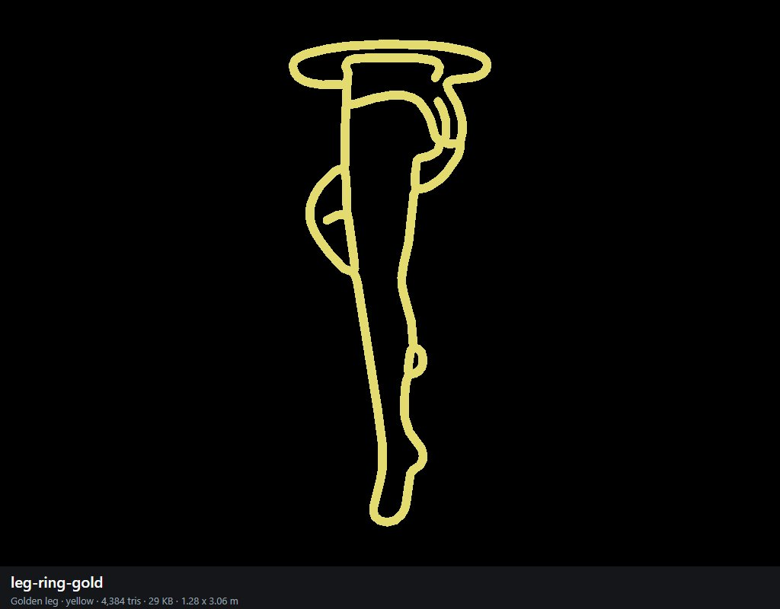

bikini-body (Bikini)
magenta; 6,736 triangles; 44 KB; 1.63 x 3.06 m as built (the shop scales it to its wall). Photo: NEON sexy / 65369ac06e351d7b9358ae8d-lady-neon-signs-female-body-curves-neon.jpg.
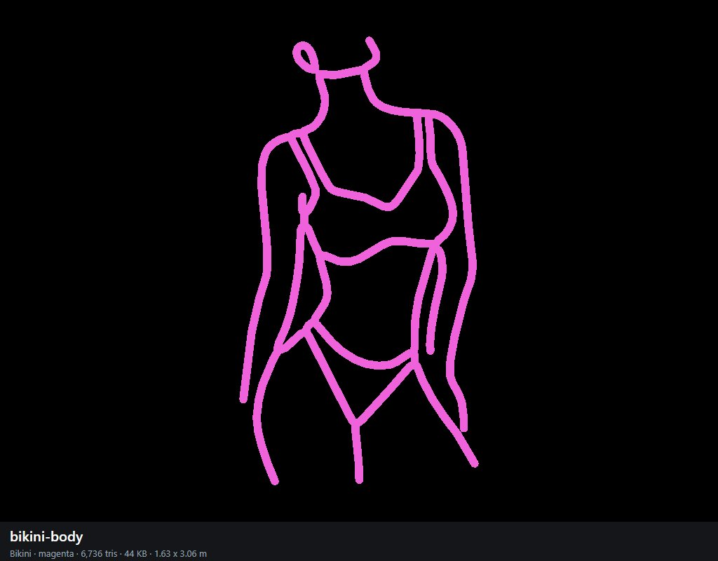

hands-hips (Hands)
cyan, pink; 10,400 triangles; 68 KB; 2.31 x 3.05 m as built (the shop scales it to its wall). Photo: NEON sexy / 719pRQA8nRL.jpg.
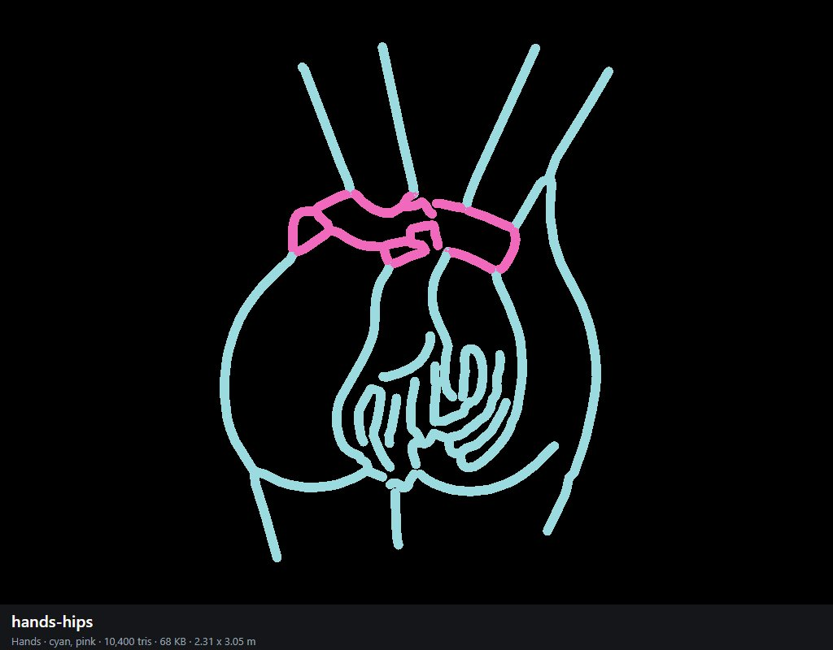

back-curves (Curves)
pink; 3,424 triangles; 23 KB; 1.72 x 3.06 m as built (the shop scales it to its wall). Photo: NEON sexy / 71cSEQD4sTL._AC_UF1000,1000_QL80_.jpg.
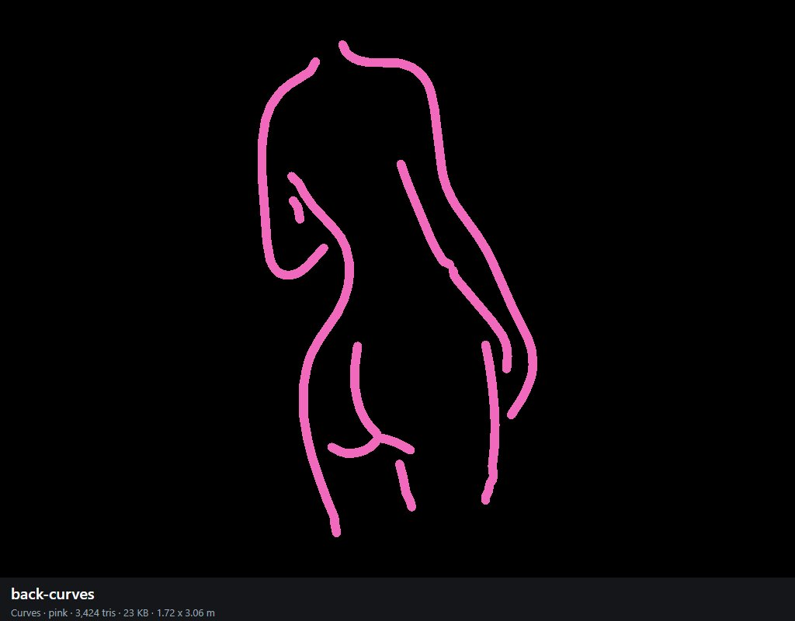

pin-up (Pin-up)
cyan, magenta; 4,912 triangles; 34 KB; 2.26 x 3.06 m as built (the shop scales it to its wall). Photo: NEON sexy / 761b6034e413b377b0515cba25dda2e63397edff73138f07aaea5eac426e593e.webp.
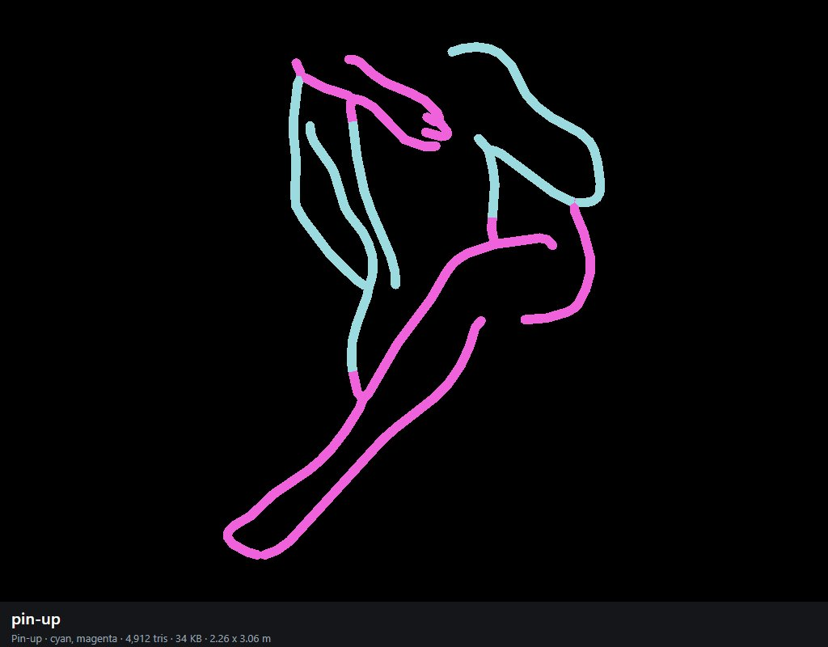

leg-ring-violet (Violet leg)
purple; 4,960 triangles; 33 KB; 1.19 x 3.06 m as built (the shop scales it to its wall). Photo: NEON sexy / 81XF1uT2IfL._AC_SL1500_.jpg.
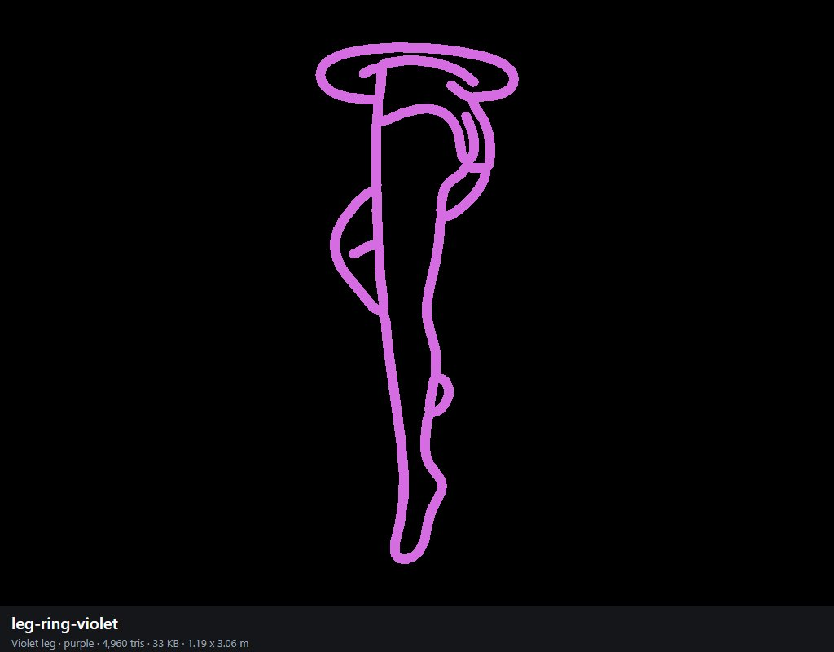

lips-strawberry (Strawberry lips)
green, magenta, pink, red, white; 13,008 triangles; 88 KB; 2.06 x 3.06 m as built (the shop scales it to its wall). Photo: NEON sexy / Glowneon-Sexy-Lips-Neon-Sign-Sexy-Mouth-Led-Sign-Strawberry-Neon-5.jpeg.
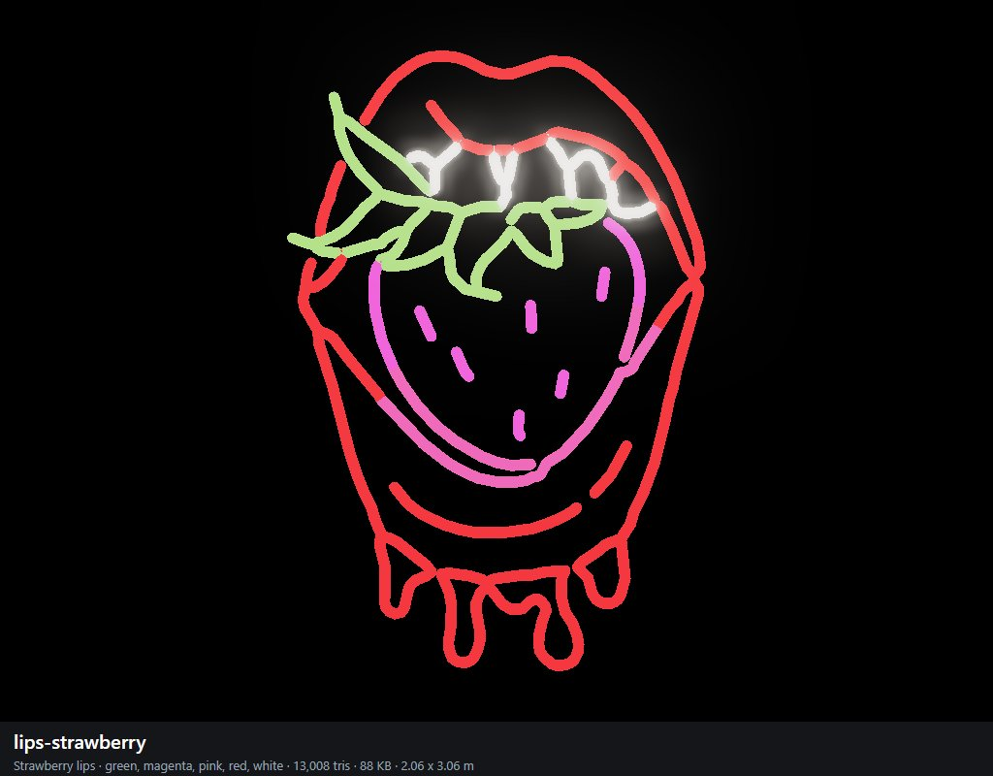

heels-crossed (Crossed legs)
orange, white; 4,496 triangles; 31 KB; 2.48 x 3.06 m as built (the shop scales it to its wall). Photo: NEON sexy / Legs 512.jpg.
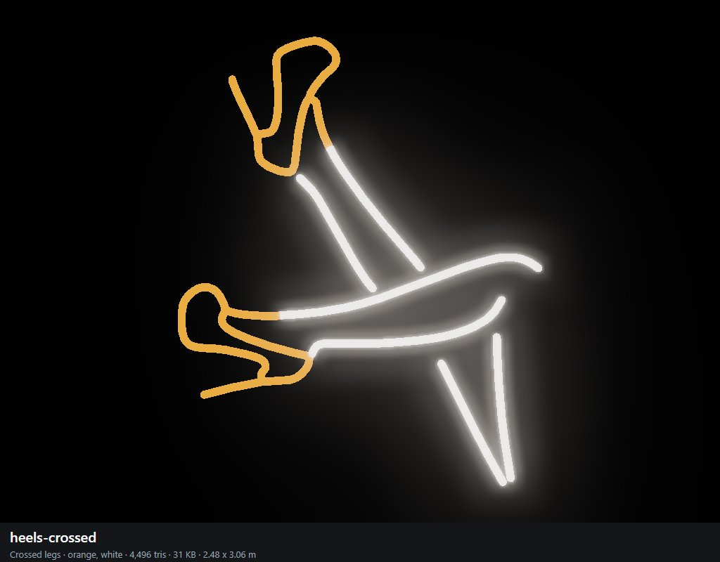

bad-girl (Bad girl)
pink; 7,344 triangles; 48 KB; 1.25 x 3.06 m as built (the shop scales it to its wall). Photo: NEON sexy / Sexy_Bad_Girl_Middle_Finger_LED_Neon_Sign_bd5d5415.webp.
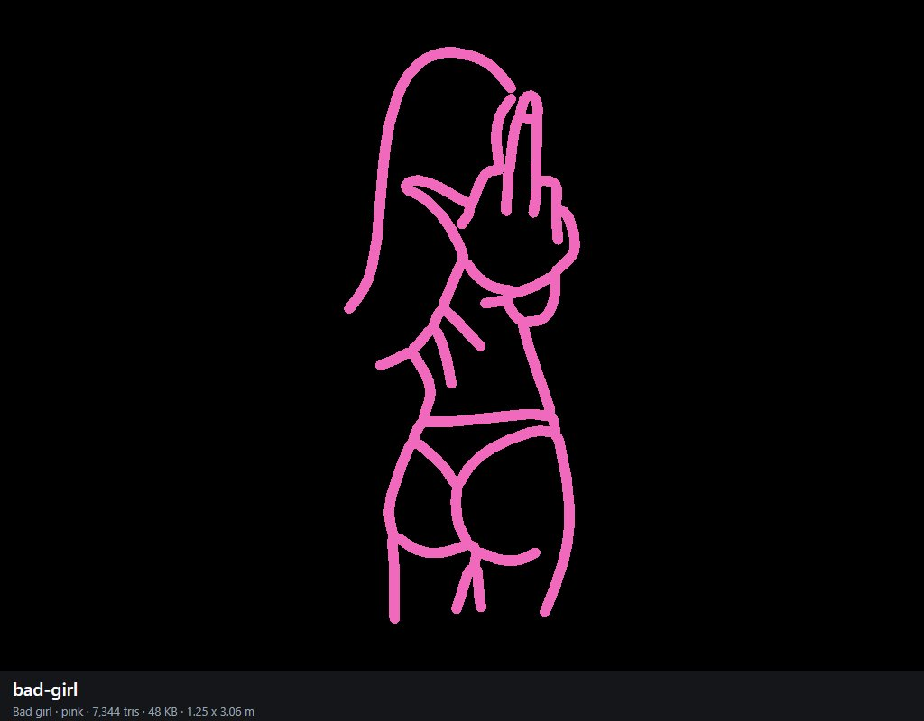

biting-lip (Biting lip)
magenta, pink, white; 6,256 triangles; 43 KB; 3.06 x 2.23 m as built (the shop scales it to its wall). Photo: NEON sexy / biting-lip-neon-sign-sexy-neon-light-bedroom-neon-sign-297783.webp.
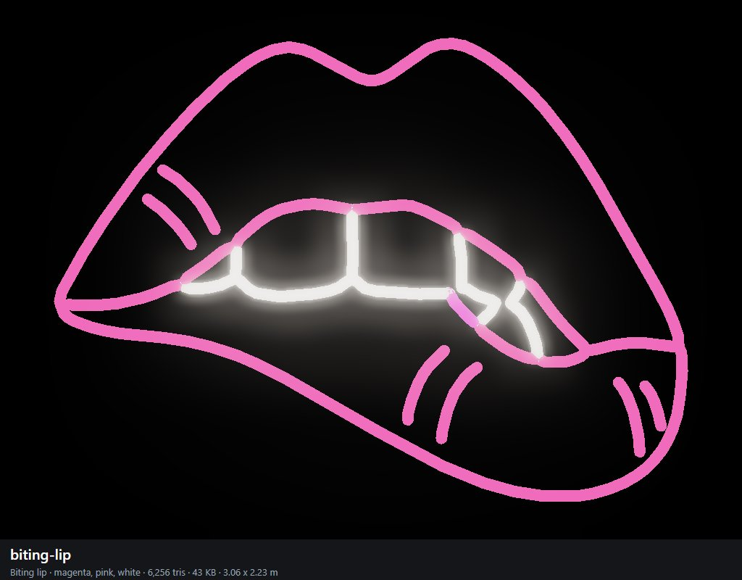

leggings (Leggings)
purple, white; 3,488 triangles; 24 KB; 0.96 x 3.07 m as built (the shop scales it to its wall). Photo: NEON sexy / il_300x300.4878921754_qedo.webp.
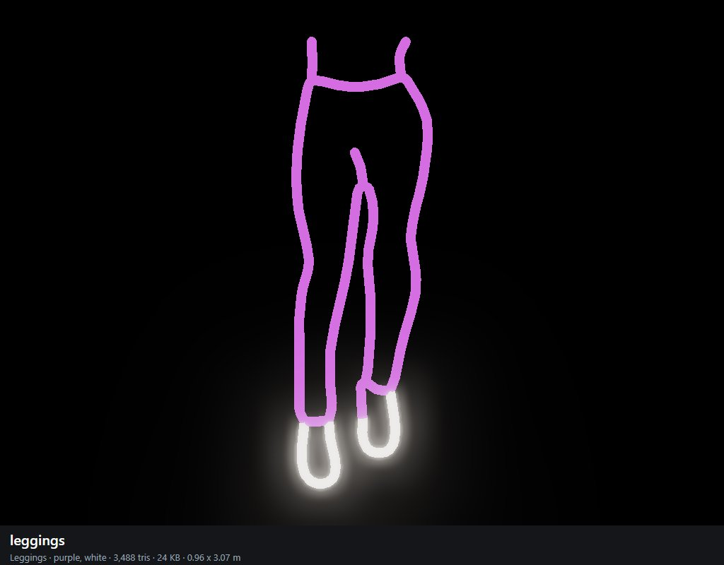

bikini-pose (Bikini pose)
magenta; 6,240 triangles; 41 KB; 2.04 x 3.06 m as built (the shop scales it to its wall). Photo: NEON sexy / il_570xN.4756069899_slnc.webp.
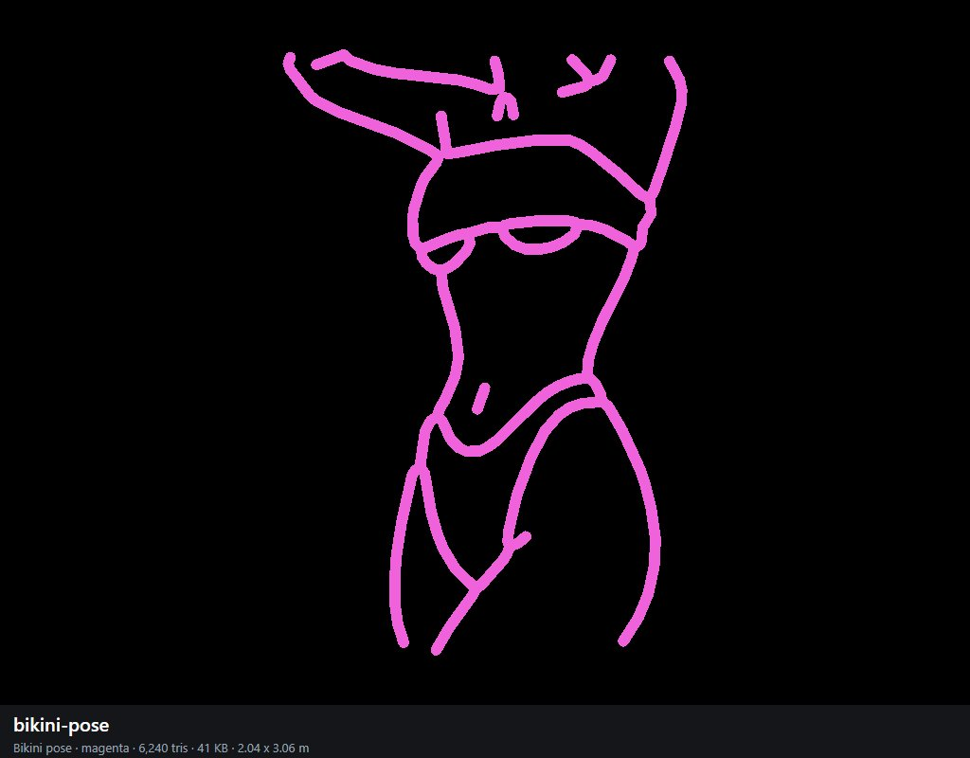

shh (Shh)
magenta, white, yellow; 5,616 triangles; 39 KB; 2.12 x 3.06 m as built (the shop scales it to its wall). Photo: NEON sexy / images (1).jfif.
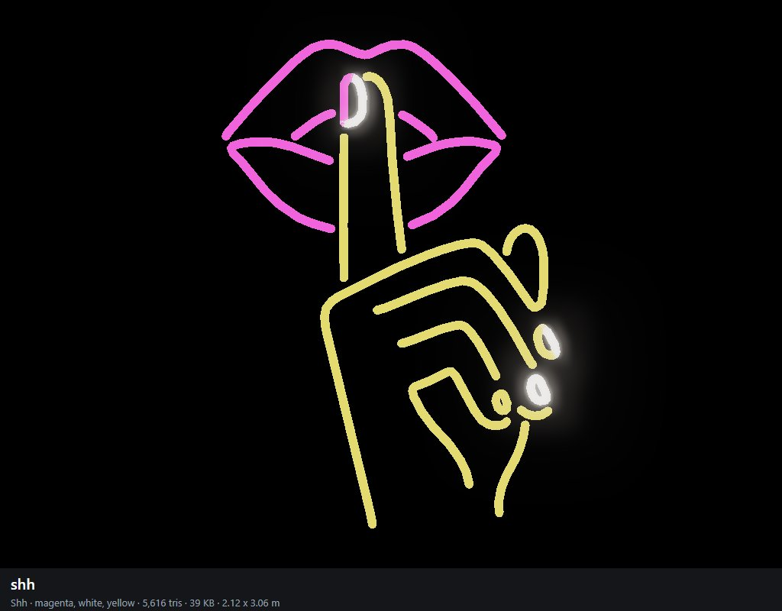

high-heels-open (High heels open)
green, red, yellow; 12,528 triangles; 82 KB; 2.41 x 3.07 m as built (the shop scales it to its wall). Photo: NEON sexy / images (1).png.
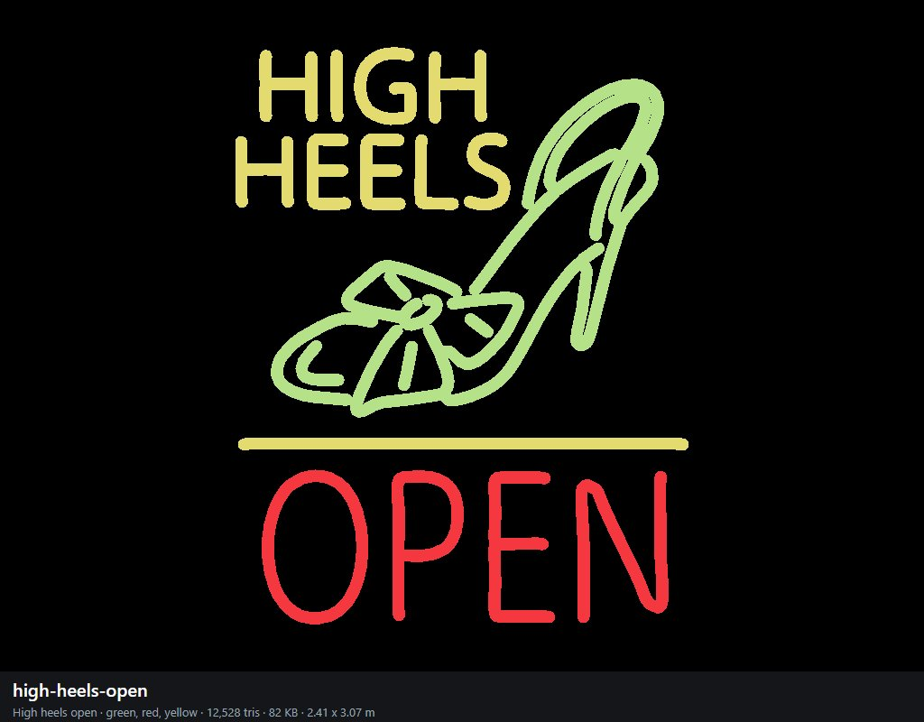

stockings (Stockings)
pink, red; 6,416 triangles; 43 KB; 2.42 x 3.05 m as built (the shop scales it to its wall). Photo: NEON sexy / images (2).jfif.
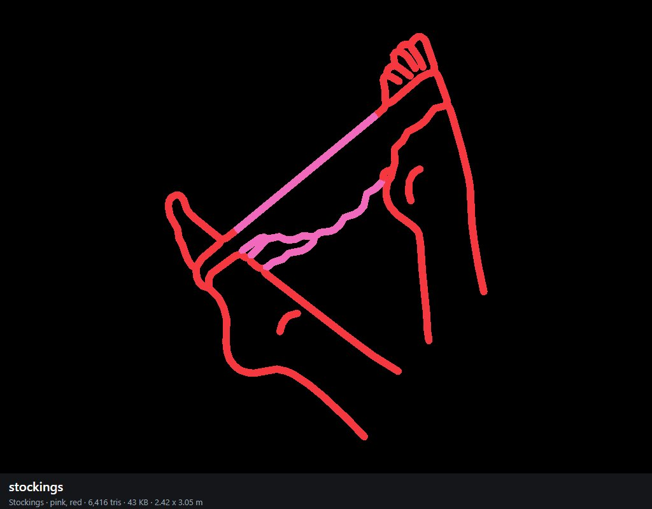

reclining (Reclining)
magenta; 6,688 triangles; 44 KB; 3.06 x 2.14 m as built (the shop scales it to its wall). Photo: NEON sexy / images (3).jfif.
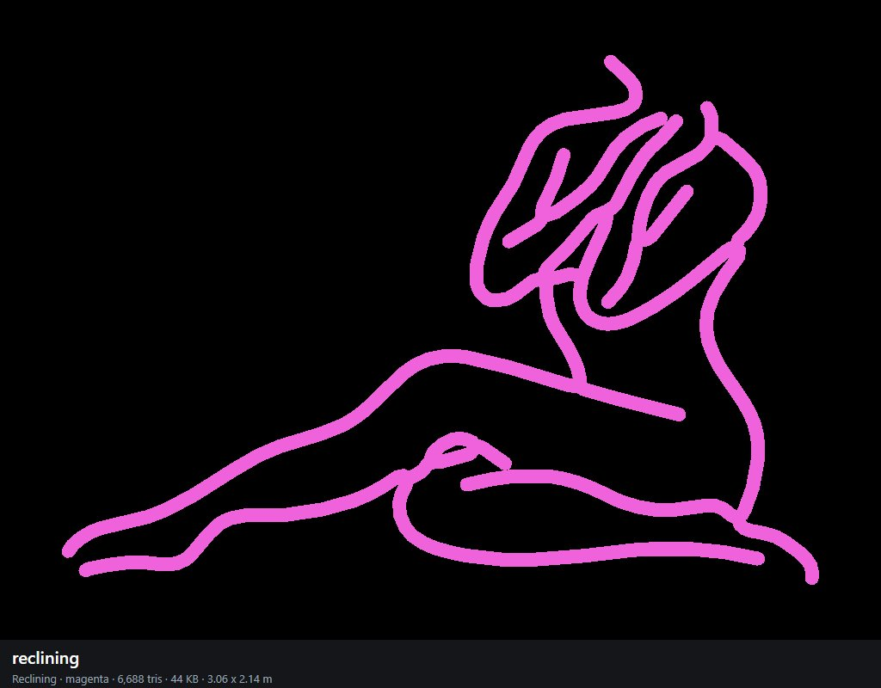

silhouette (Silhouette)
magenta; 7,360 triangles; 48 KB; 1.67 x 3.06 m as built (the shop scales it to its wall). Photo: NEON sexy / images.jfif.
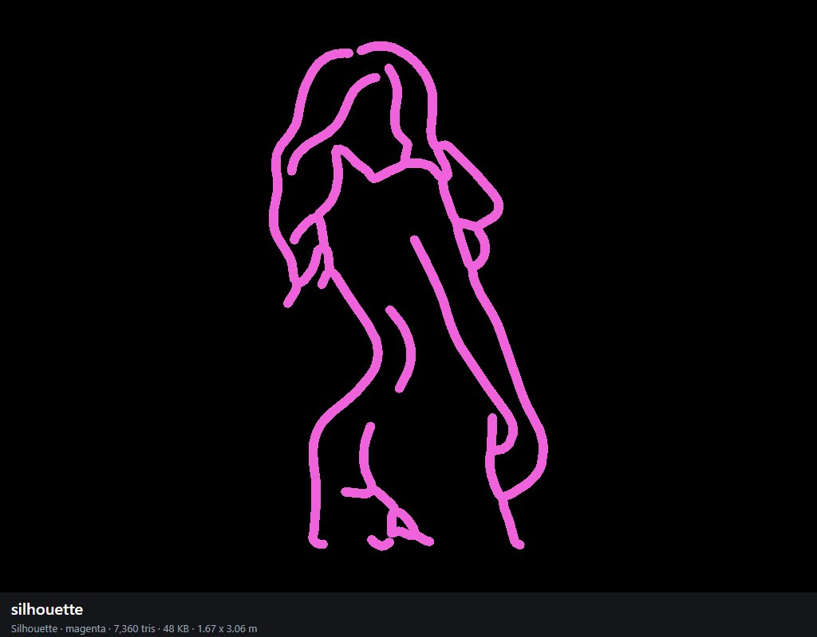

stiletto (Stiletto)
red; 2,256 triangles; 16 KB; 3.07 x 3.05 m as built (the shop scales it to its wall). Photo: NEON sexy / images.png.
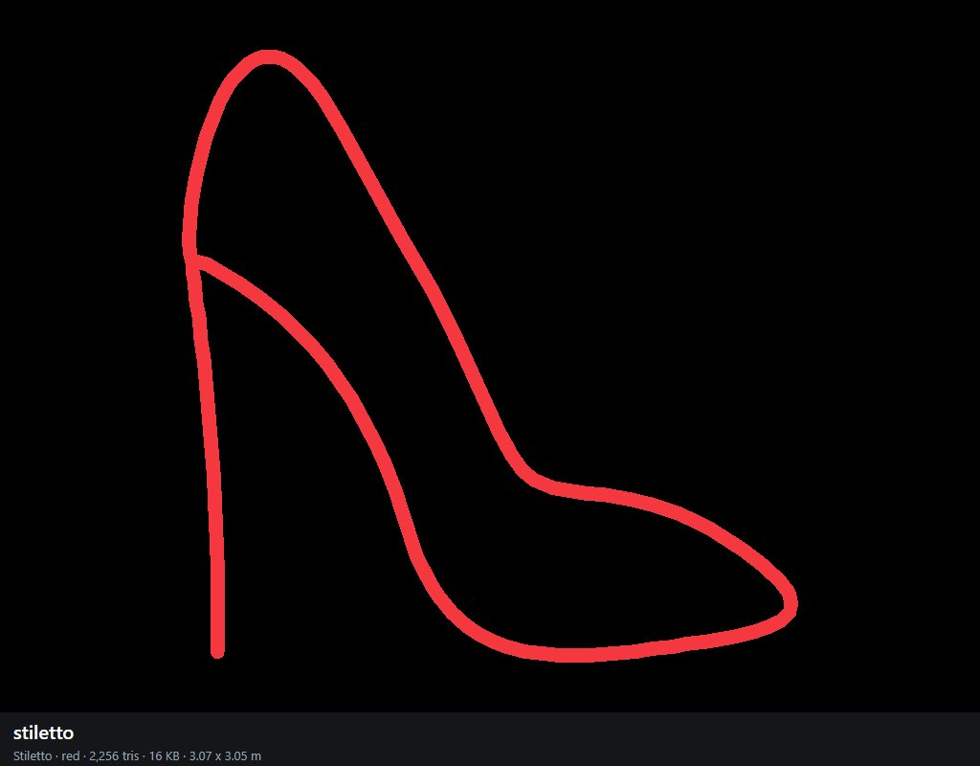

high-heels (High heels)
red, white, yellow; 10,784 triangles; 69 KB; 3.06 x 1.58 m as built (the shop scales it to its wall). Photo: NEON sexy / n105-12003-yellow-high-heels-with-logo-neon-sign.jpg.
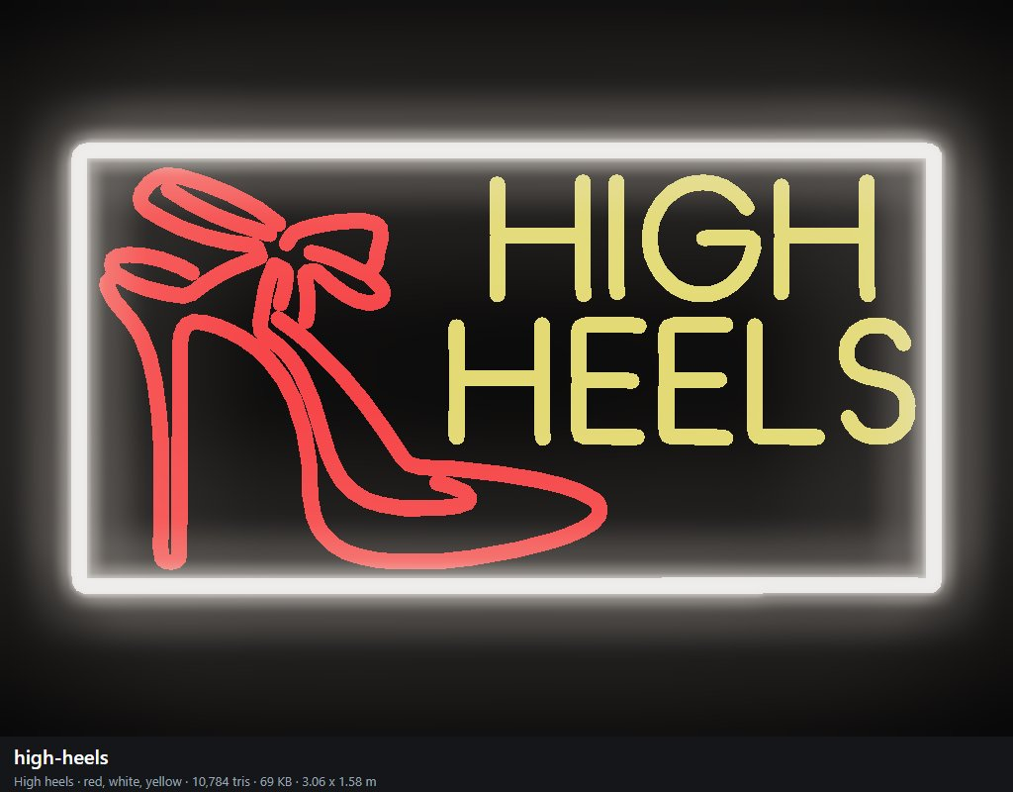

grab (Grab)
magenta; 6,336 triangles; 42 KB; 2.56 x 3.08 m as built (the shop scales it to its wall). Photo: NEON sexy / non-femmes-sexy-logo-led-usb.webp.
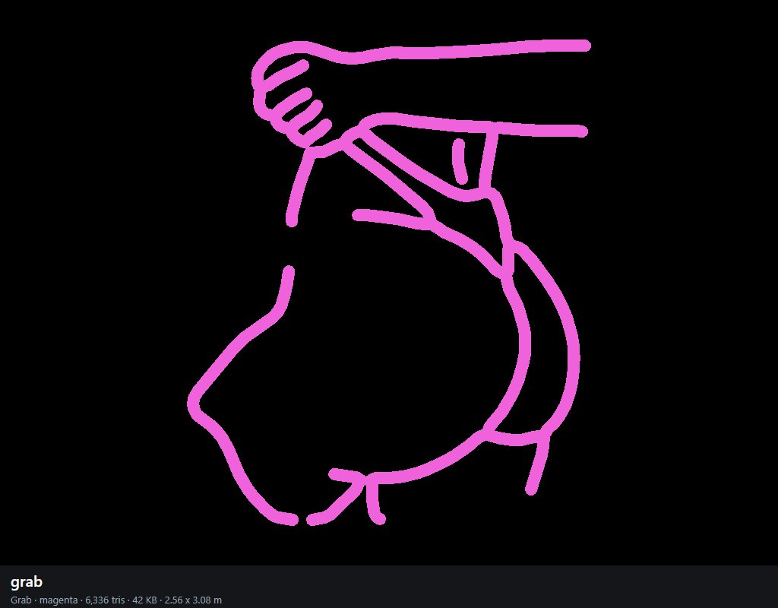

standing-woman (Standing woman)
orange; 6,336 triangles; 41 KB; 1.33 x 3.06 m as built (the shop scales it to its wall). Photo: more Neon sexy / 055ea839dbf33d81924b65855c345630_200aa18851271cece323c153c6e26638.avif.
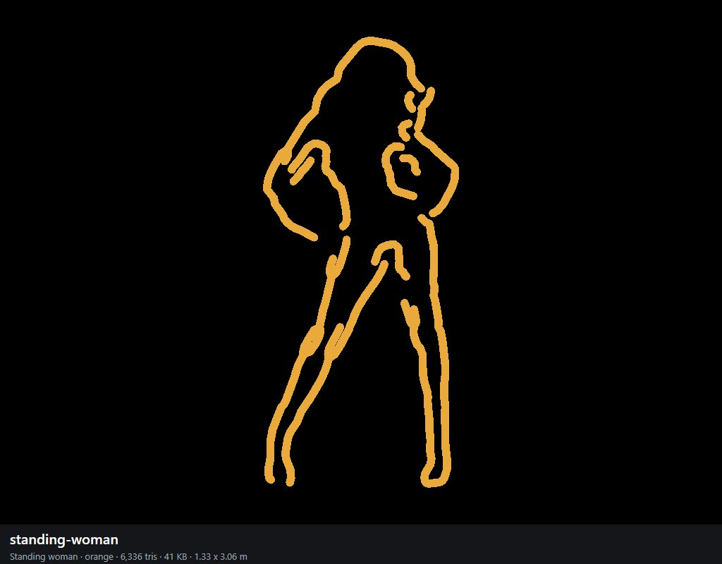

flamingo (Flamingo)
pink; 3,232 triangles; 22 KB; 1.51 x 3.06 m as built (the shop scales it to its wall). Photo: more Neon sexy / 103570e595b1300a9ded42476605cba6.jpg.
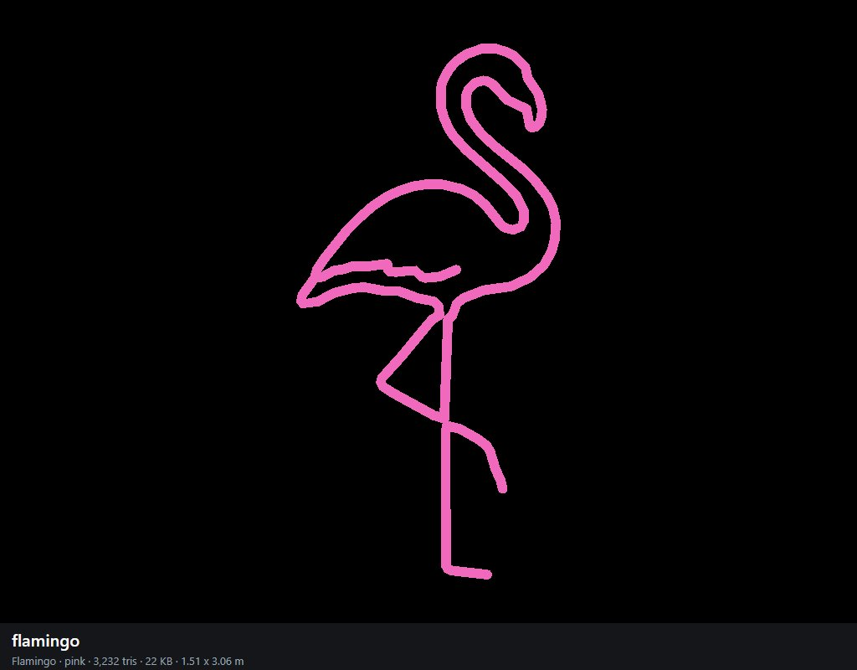

white-legs (White legs)
white; 3,104 triangles; 21 KB; 1.39 x 3.06 m as built (the shop scales it to its wall). Photo: more Neon sexy / 1X8MNK2150.webp.
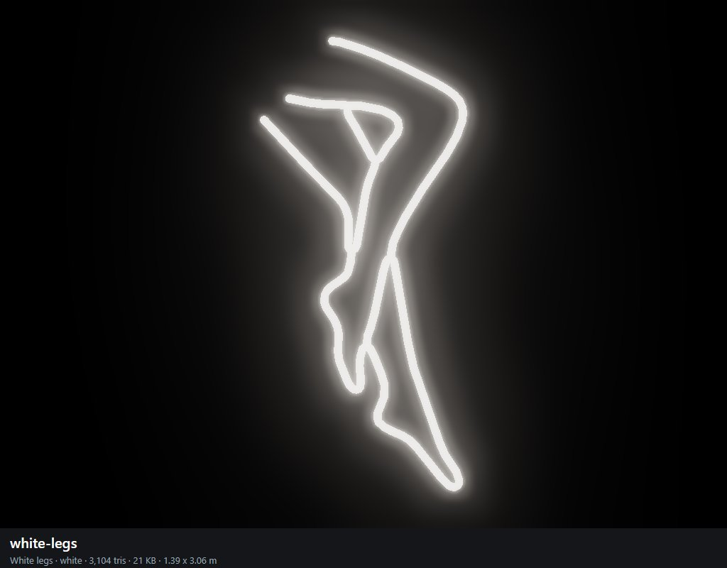

pin-up-colour (Colour pin-up)
blue, magenta, orange, pink, purple, red, white; 9,696 triangles; 69 KB; 2.02 x 3.06 m as built (the shop scales it to its wall). Photo: more Neon sexy / 510c7d06d5994a87bed66abc7a27fe23.jpg.
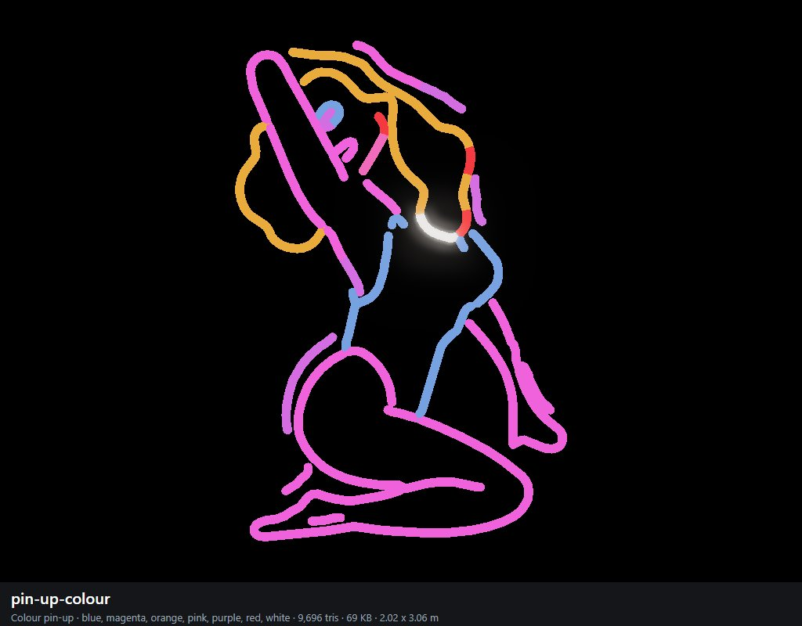

bikini-white (White bikini)
blue, magenta, purple, white; 7,536 triangles; 53 KB; 2.46 x 3.05 m as built (the shop scales it to its wall). Photo: more Neon sexy / 51snQgGS3lL.jpg.
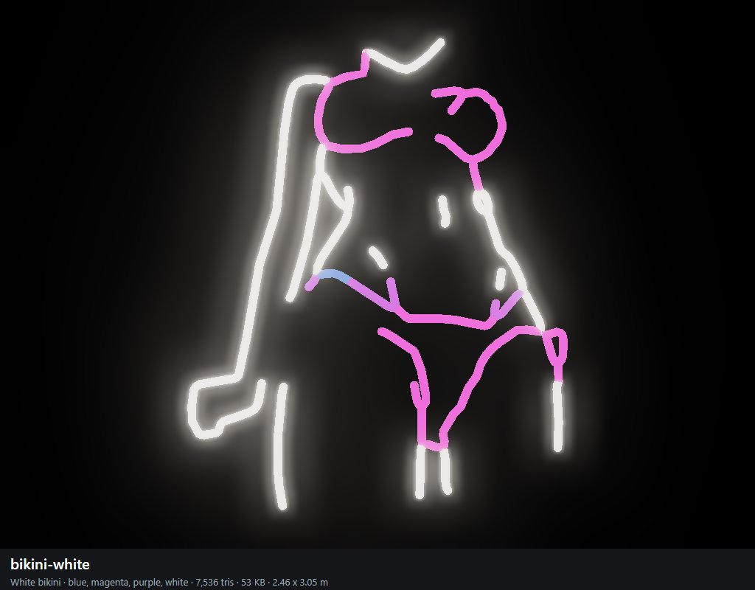

lips-tongue (Tongue)
magenta, pink, purple, red; 7,248 triangles; 51 KB; 3.07 x 2.95 m as built (the shop scales it to its wall). Photo: more Neon sexy / 64e67d0391b0af4870384077-nosun-lips-tongue-neon-sign-red-lips.jpg.
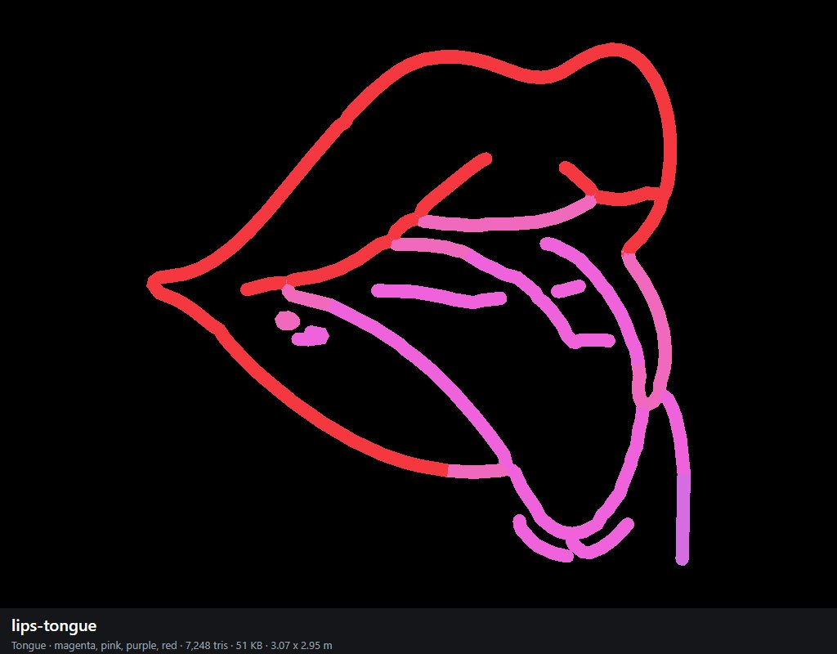

yellow-lady (Yellow lady)
magenta, orange, pink, yellow; 8,704 triangles; 60 KB; 1.97 x 3.06 m as built (the shop scales it to its wall). Photo: more Neon sexy / 6930958a-7244-42a4-b27d-8e5179fba561.jpg. Cut out of a photo of several signs.
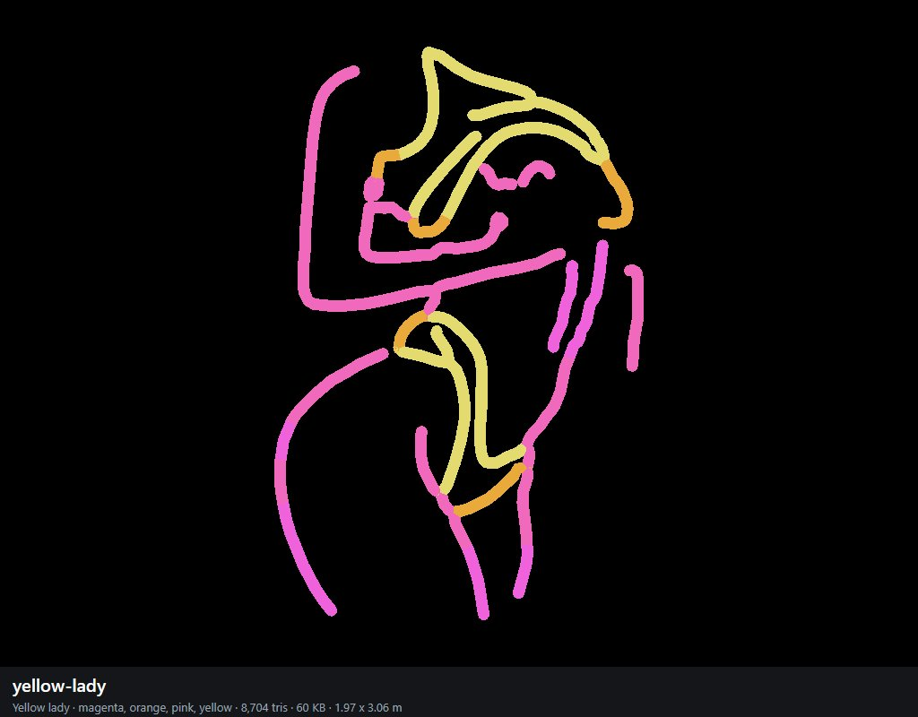

cowgirl (Cowgirl)
magenta, orange, pink, yellow; 8,880 triangles; 61 KB; 2.12 x 3.06 m as built (the shop scales it to its wall). Photo: more Neon sexy / 6930958a-7244-42a4-b27d-8e5179fba561.jpg. Cut out of a photo of several signs.
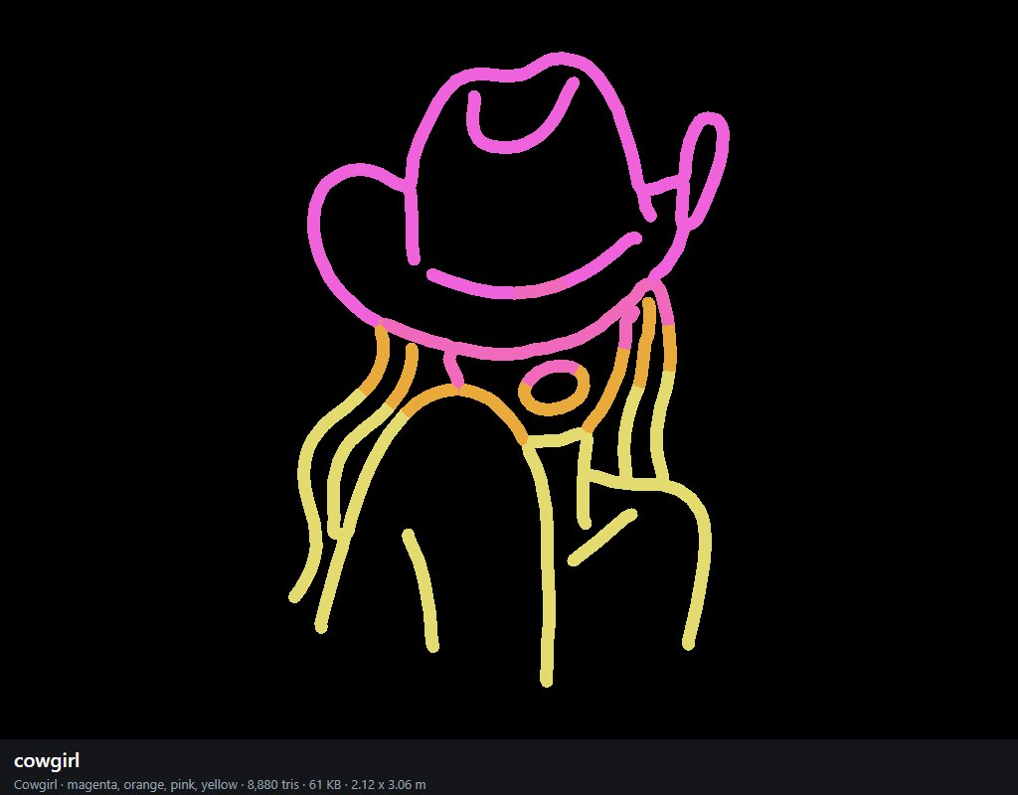

legs-heels (Legs & heels)
magenta, pink; 5,872 triangles; 40 KB; 2.40 x 3.06 m as built (the shop scales it to its wall). Photo: more Neon sexy / 6930958a-7244-42a4-b27d-8e5179fba561.jpg. Cut out of a photo of several signs.
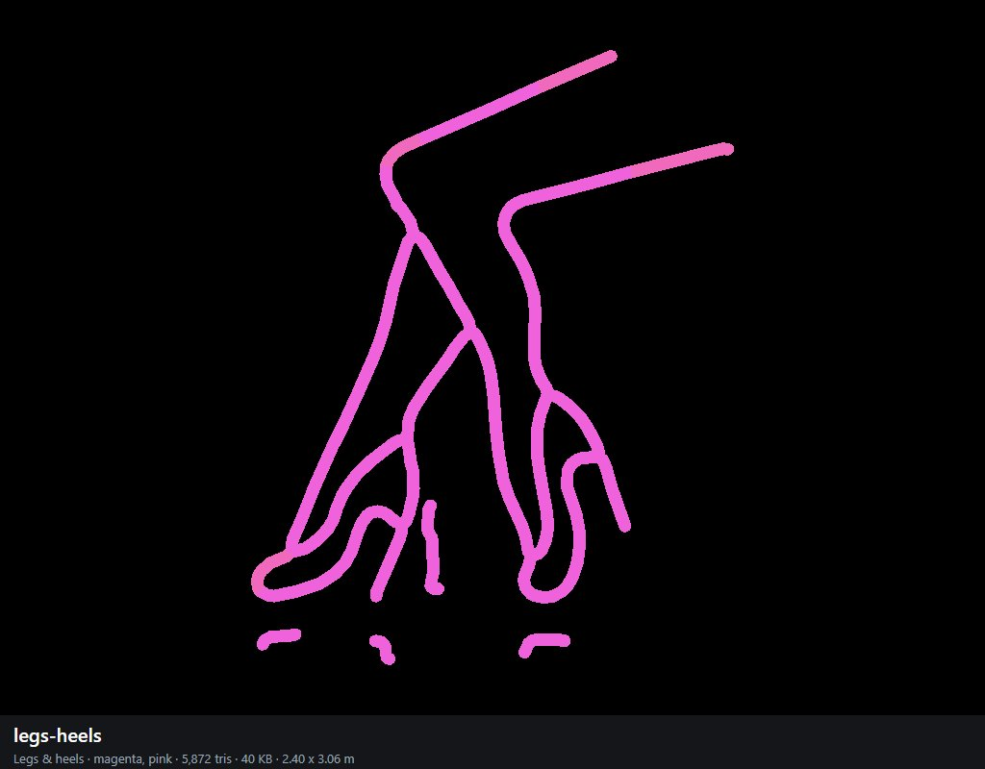

smoking-hand (Smoke)
blue, magenta, purple; 6,704 triangles; 46 KB; 2.13 x 3.06 m as built (the shop scales it to its wall). Photo: more Neon sexy / 71LX0cTetAL._AC_UL450_SY450_QL70_.jpg.
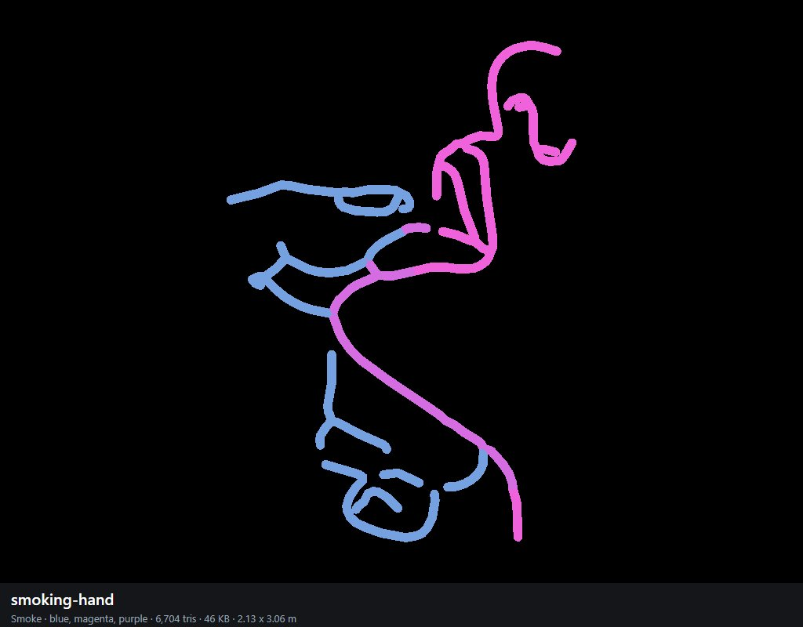

wine-lady (Wine lady)
magenta; 6,224 triangles; 41 KB; 1.95 x 3.07 m as built (the shop scales it to its wall). Photo: more Neon sexy / 71Upj74bQwL.webp.
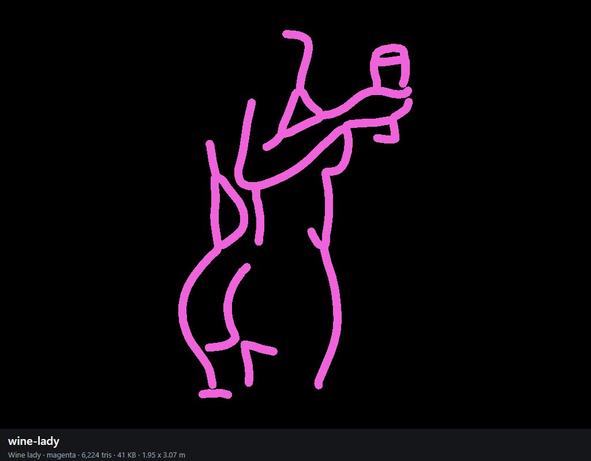

bow (Bow)
pink; 4,048 triangles; 27 KB; 3.05 x 2.95 m as built (the shop scales it to its wall). Photo: more Neon sexy / 81R-vKZwhwL._AC_UL495_SR435,495_.jpg.
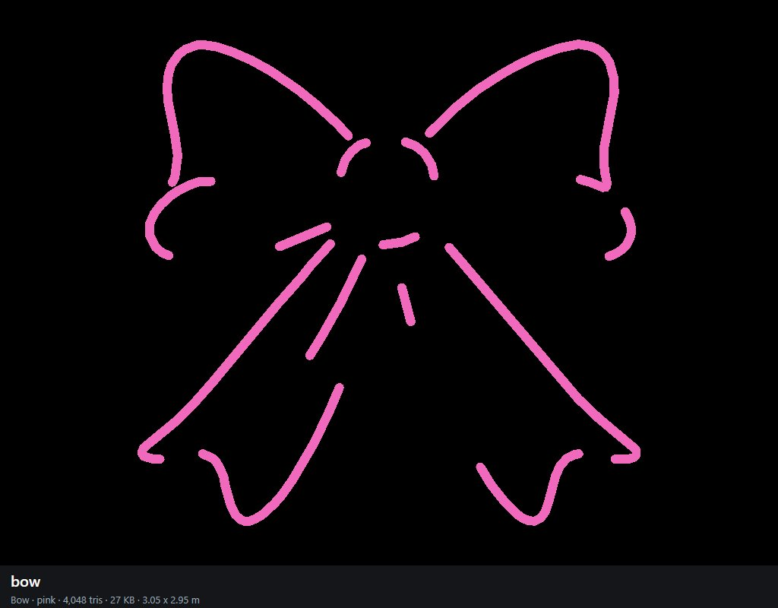

flame (Flame)
orange, red, yellow; 3,056 triangles; 23 KB; 2.34 x 3.09 m as built (the shop scales it to its wall). Photo: more Neon sexy / 81VrnT4fZQL._AC_UL450_SY450_QL70_.jpg.
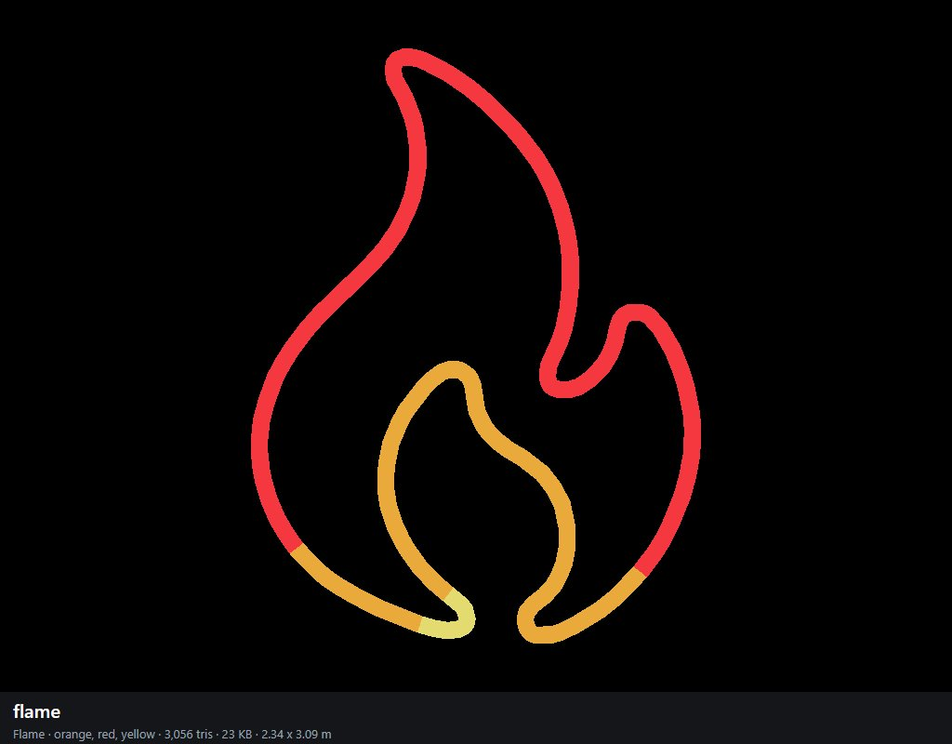

back-amber (Amber back)
orange; 4,336 triangles; 29 KB; 1.58 x 3.06 m as built (the shop scales it to its wall). Photo: more Neon sexy / He4dd4a02ee2347a9948dfdc38fb9faa0l.webp.
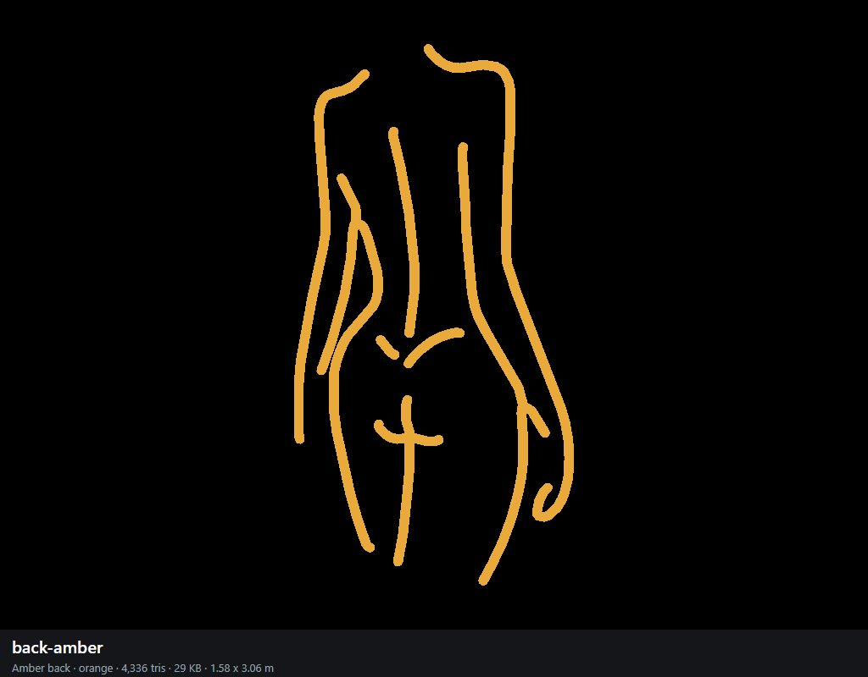

tied-legs (Tied legs)
blue, cyan, magenta, purple; 9,104 triangles; 62 KB; 3.07 x 2.32 m as built (the shop scales it to its wall). Photo: more Neon sexy / Hea401391fbbd4312b70502e97ef00620j.avif.
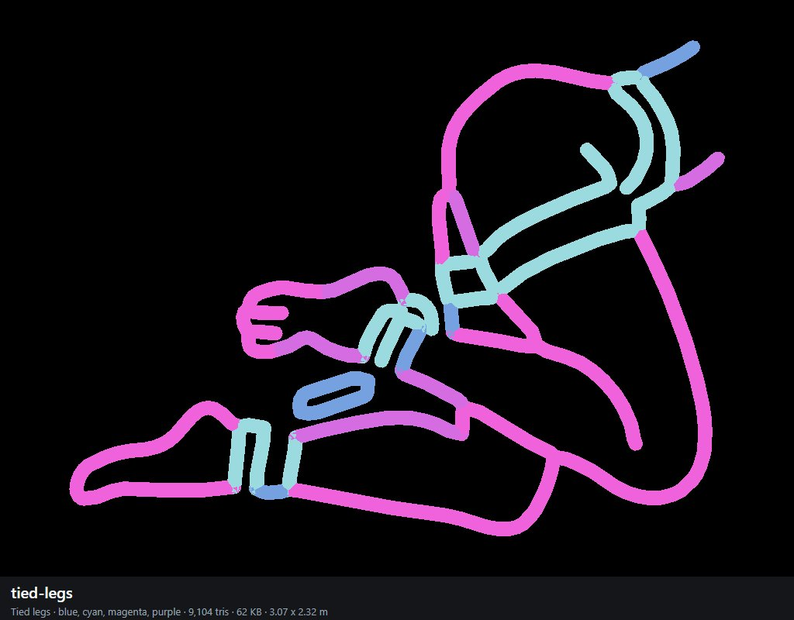

back-hat (Hat)
magenta, pink, white; 6,960 triangles; 47 KB; 1.58 x 3.07 m as built (the shop scales it to its wall). Photo: more Neon sexy / Lady+Neon+Signs+Neon+Signs+For+Wall+Decor+Pink+White+LED+Light+Sign+For+Preppy+Room+Decor+Light+Up+Sign+For+Birthday+Party+Decoration+USB+Powered.webp.
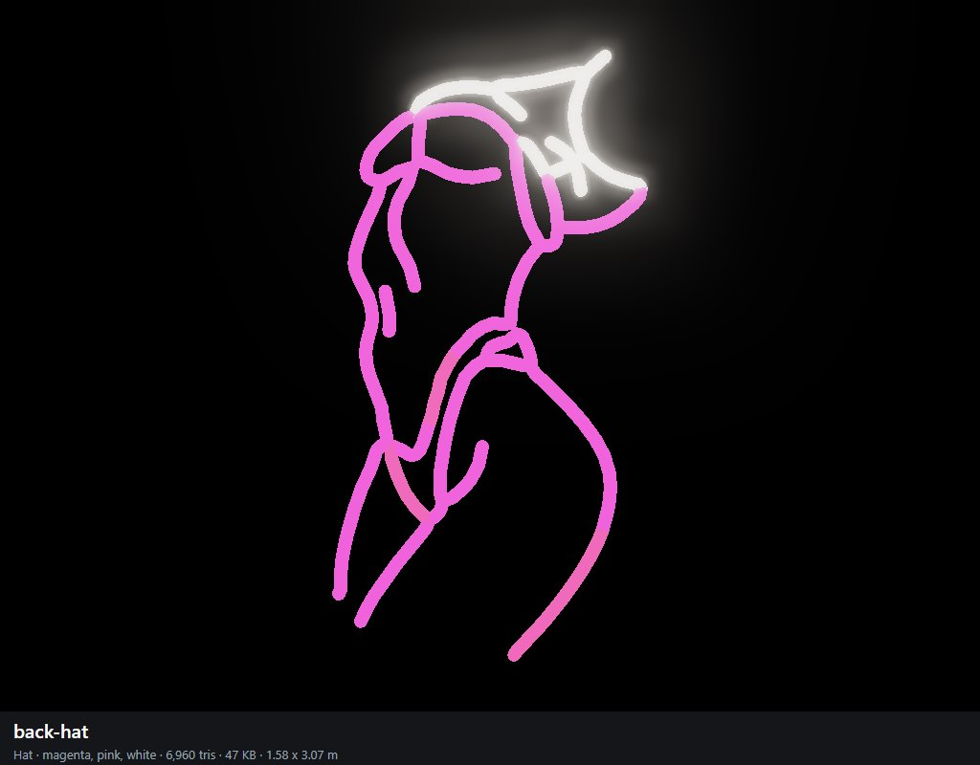

selfie (Selfie)
magenta, red, white; 14,480 triangles; 95 KB; 1.80 x 3.06 m as built (the shop scales it to its wall). Photo: more Neon sexy / Neon-Femme-Bikini-GTA-300x300.png.
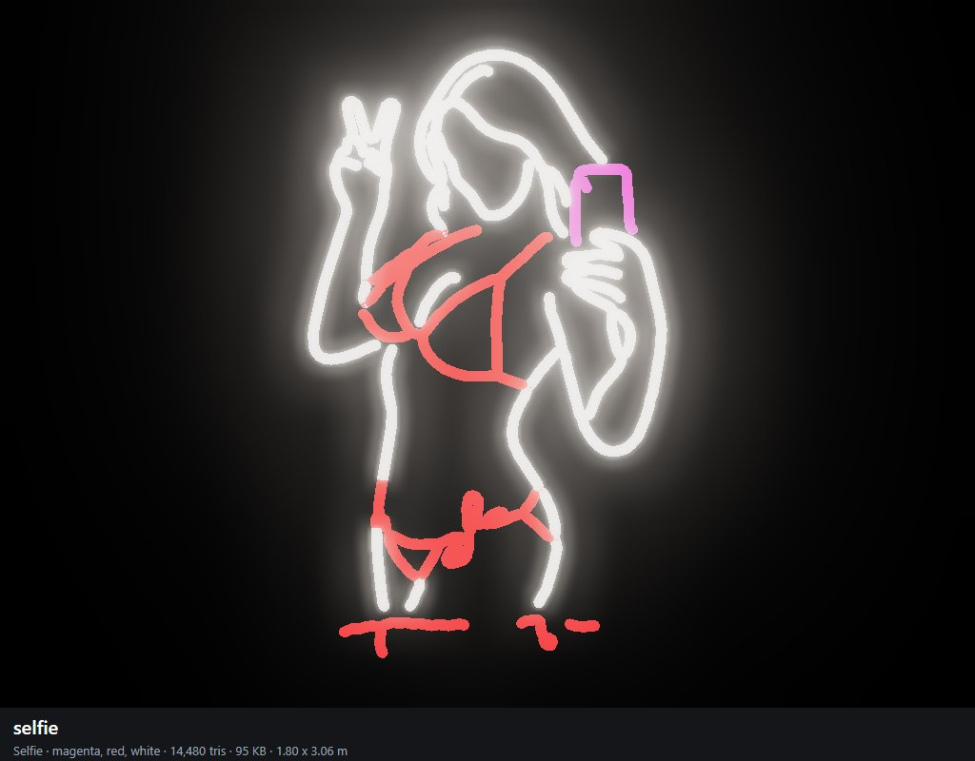

live-sex (Live Sex)
pink; 6,272 triangles; 41 KB; 3.06 x 1.74 m as built (the shop scales it to its wall). Photo: more Neon sexy / S71d298adb6f64bb896e45294306c5dd5Z.avif. Lettering drawn from a font: Live Sex.
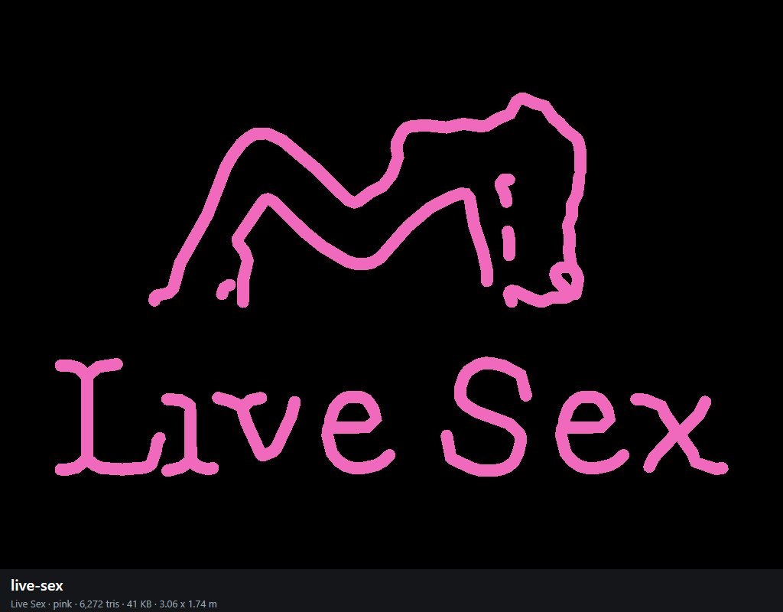

framed-finger (Framed)
blue, magenta, purple; 12,704 triangles; 83 KB; 3.06 x 2.66 m as built (the shop scales it to its wall). Photo: more Neon sexy / S835cce23af2a44ed9ec2c48d7c3a5cd5v.webp.
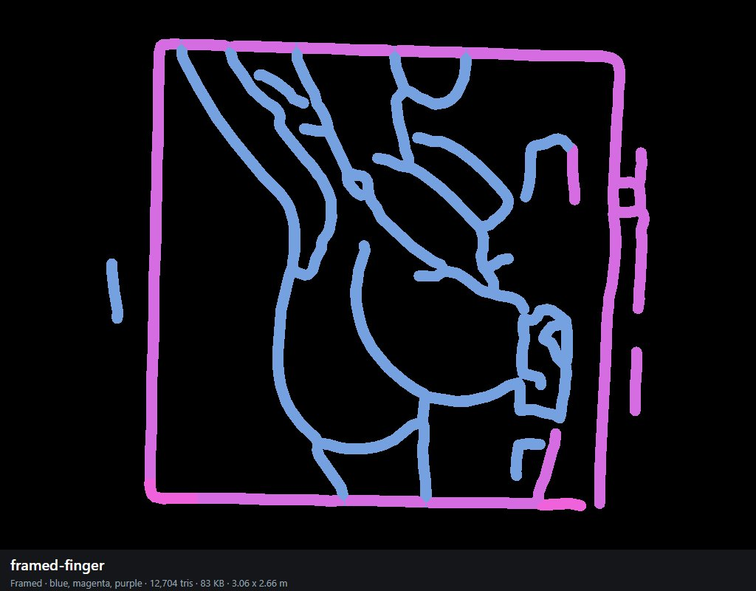

pole-dance (Dance)
magenta, white; 7,488 triangles; 50 KB; 1.73 x 3.06 m as built (the shop scales it to its wall). Photo: more Neon sexy / Sabed75abb3454c4199dd0fb0ac8ebf47G.png_480x480.png_.avif.
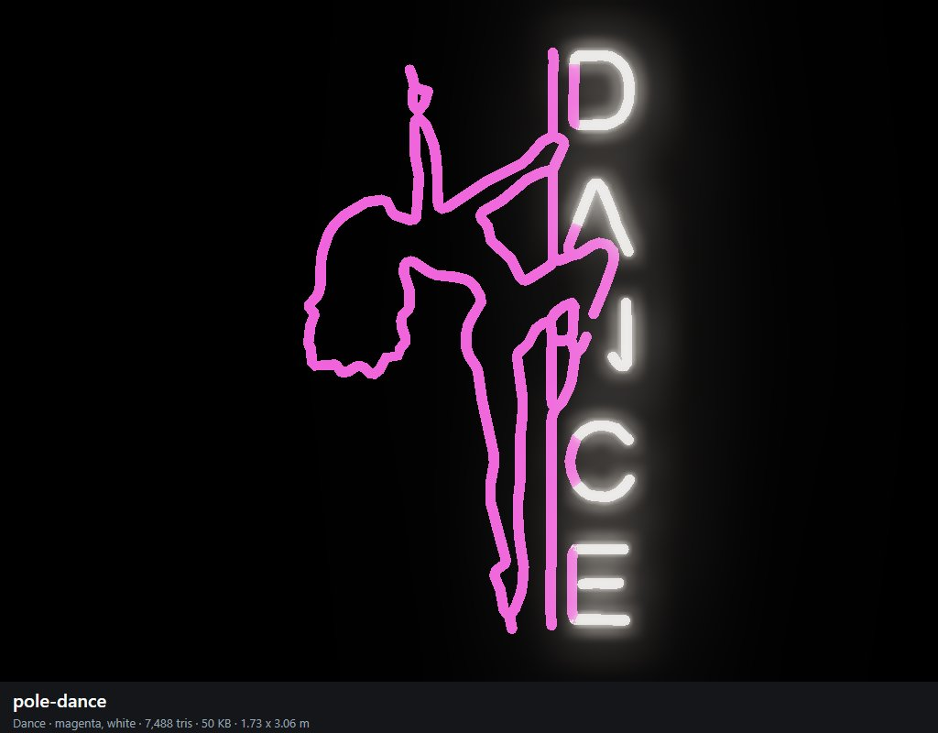

send-nudes (Send nudes)
blue, magenta, pink, red; 8,032 triangles; 55 KB; 3.06 x 1.82 m as built (the shop scales it to its wall). Photo: more Neon sexy / Send-Nudes-Neon-Sign-Body-Neon-Woman-Sign-Led-Light-red-wm_1080x.webp. Lettering drawn from a font: SEND NUDES.
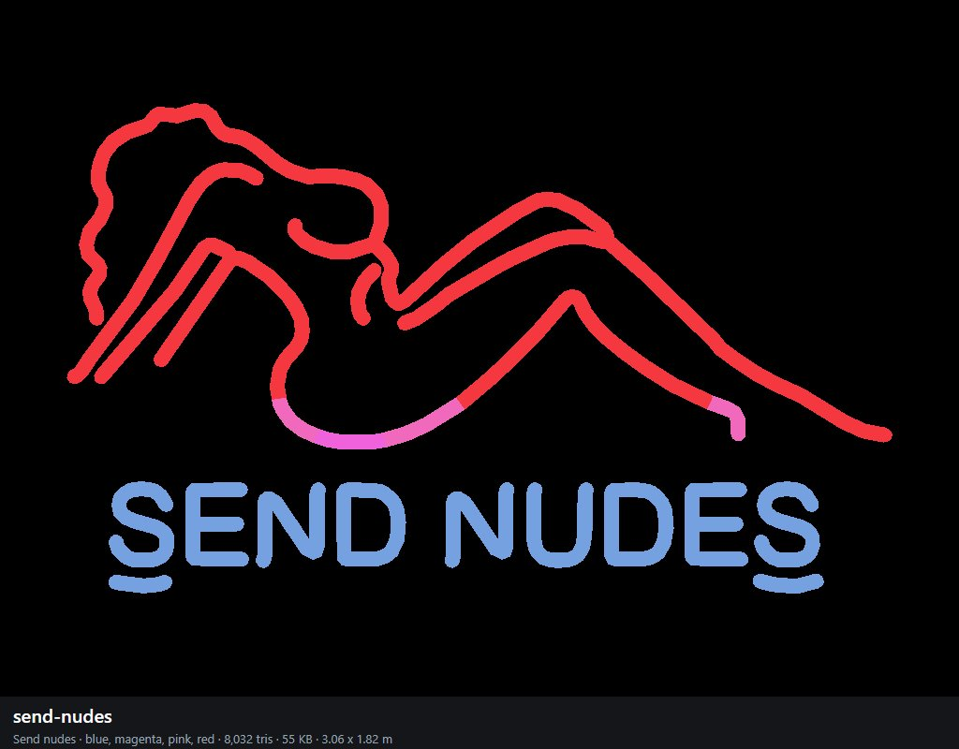

burlesque (Burlesque)
orange, red, yellow; 10,832 triangles; 72 KB; 0.76 x 3.05 m as built (the shop scales it to its wall). Photo: more Neon sexy / Waterproof-Sexy-Women-Figure-Pattern-Personalization-Wall-Sign-LED-Neon-Sign-Custom-Neon.avif.
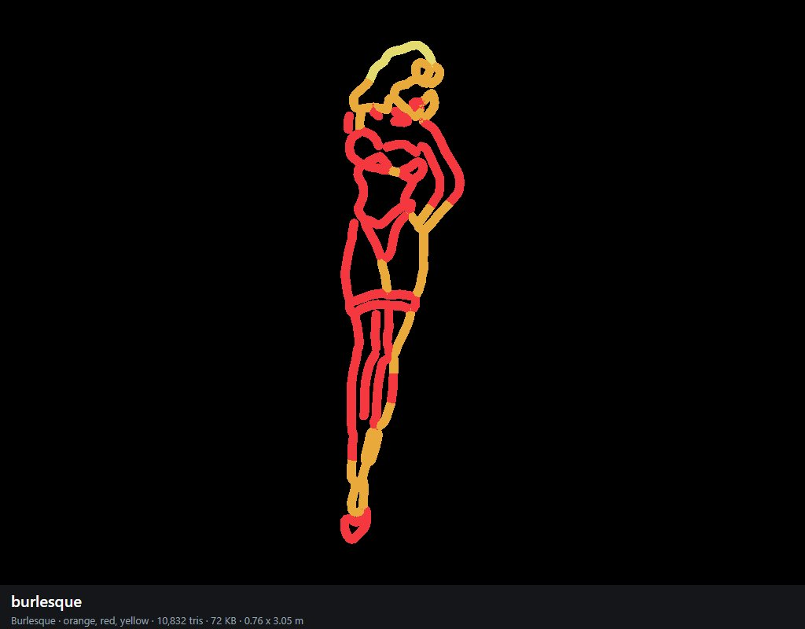

boots (Boots)
magenta, purple; 3,664 triangles; 26 KB; 2.31 x 3.09 m as built (the shop scales it to its wall). Photo: more Neon sexy / c3c5f360-4cc7-45c2-aa6c-1c82059c953e.webp.
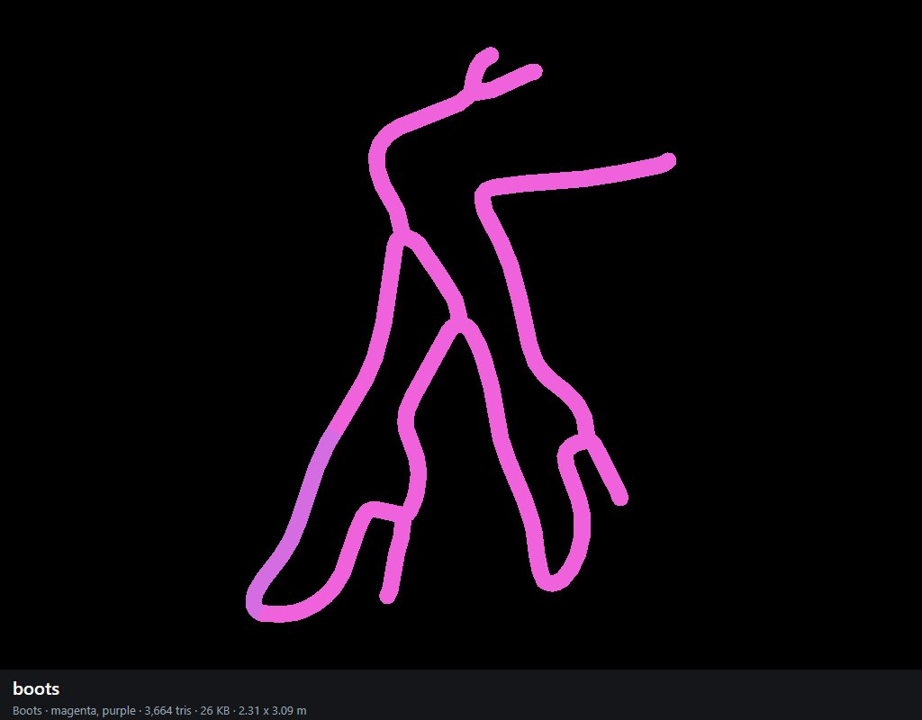

sunglasses (Sunglasses)
cyan, magenta, orange, pink, red, white, yellow; 8,128 triangles; 59 KB; 2.43 x 3.06 m as built (the shop scales it to its wall). Photo: more Neon sexy / c5a1d058-f13a-4c67-9bc9-af731cb01155.jpg.
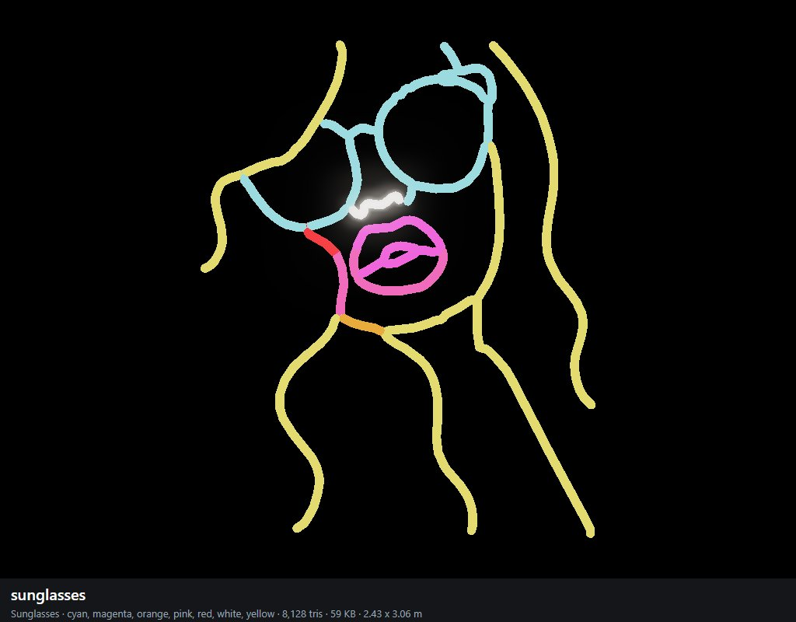

adults-only (Adults only)
orange, pink; 6,528 triangles; 43 KB; 3.06 x 1.87 m as built (the shop scales it to its wall). Photo: more Neon sexy / d13aa9939a9941518a10b23c65602a8c~tplv-fhlh96nyum-resize-webp_800_800.webp. Lettering drawn from a font: ADULTS / NLY.
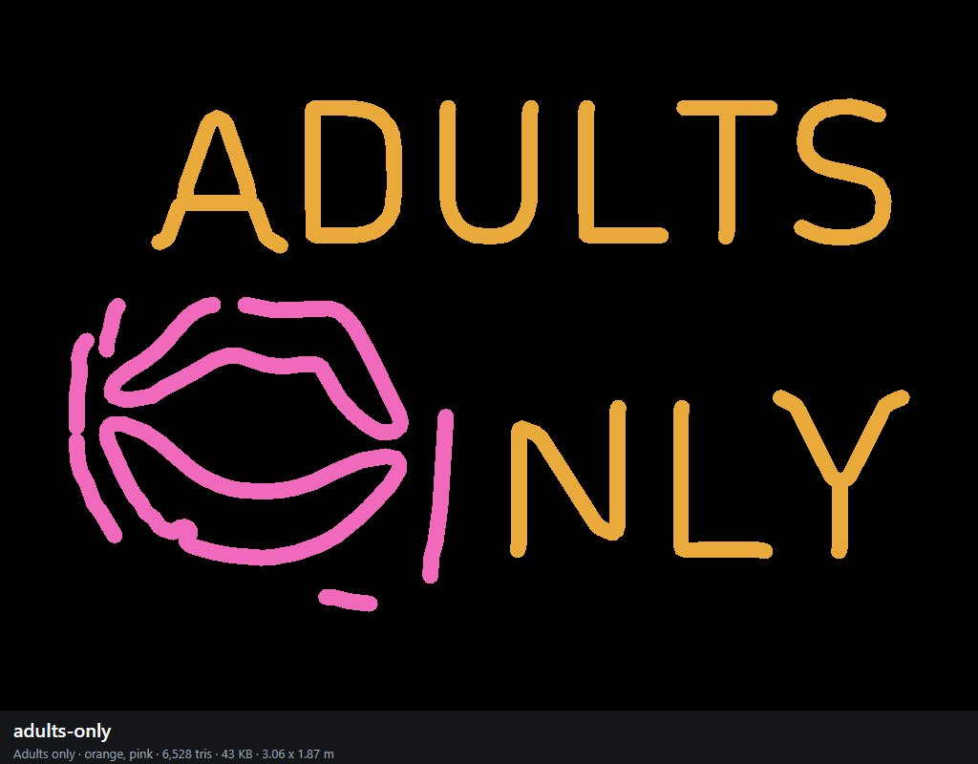

anime-bikini (Manga bikini)
blue, cyan, magenta, purple; 17,120 triangles; 113 KB; 1.59 x 3.06 m as built (the shop scales it to its wall). Photo: more Neon sexy / ersetze_das_neonschild_202604111024.avif.
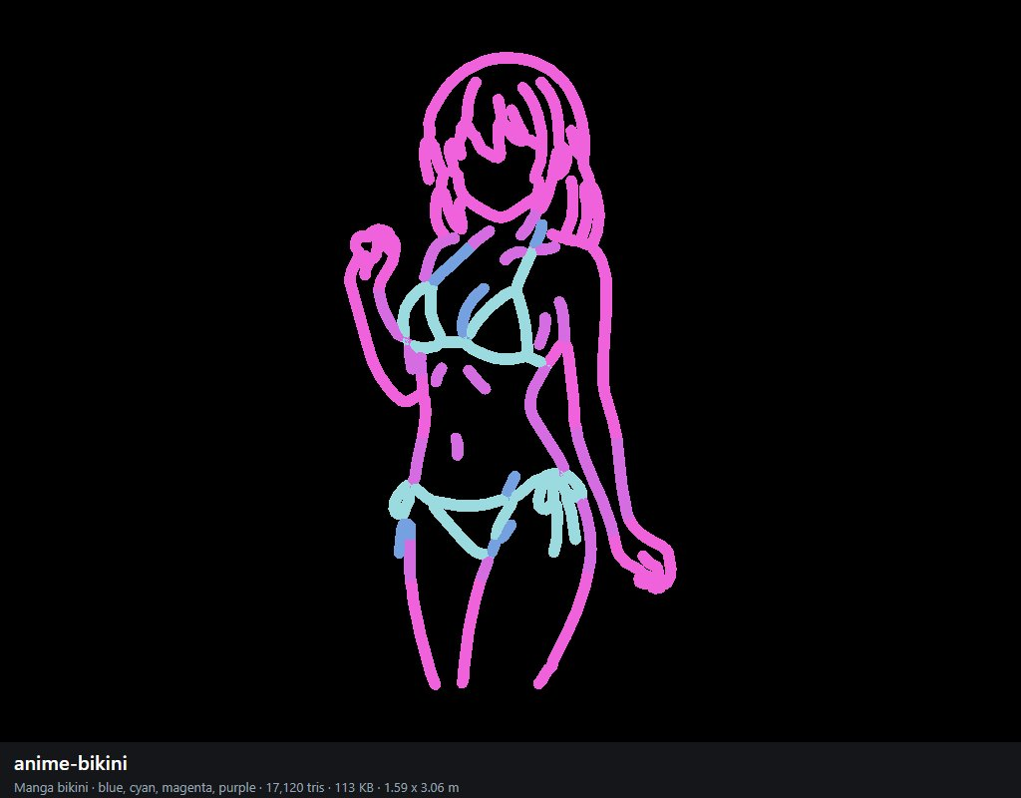

banana (Banana)
cyan, yellow; 3,456 triangles; 25 KB; 1.86 x 3.09 m as built (the shop scales it to its wall). Photo: more Neon sexy / il_1080xN.6302698191_9qv7.avif.
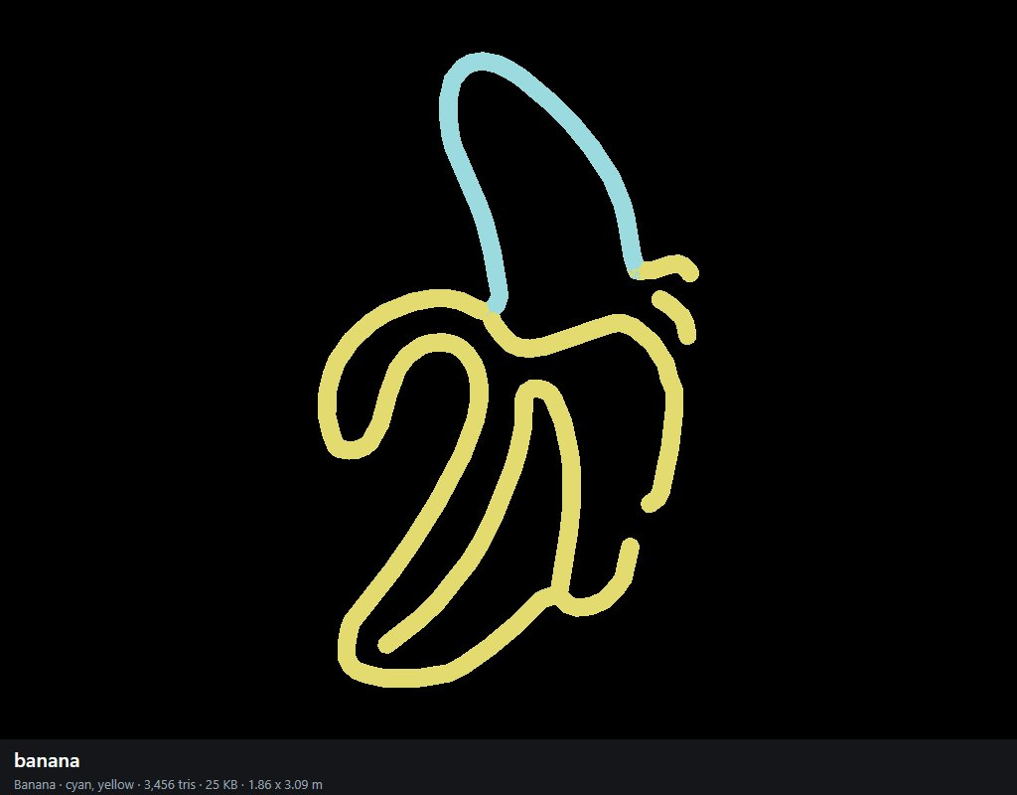

bust (Bust)
red; 3,200 triangles; 22 KB; 2.44 x 3.05 m as built (the shop scales it to its wall). Photo: more Neon sexy / il_300x300.6151516614_guuj.webp.
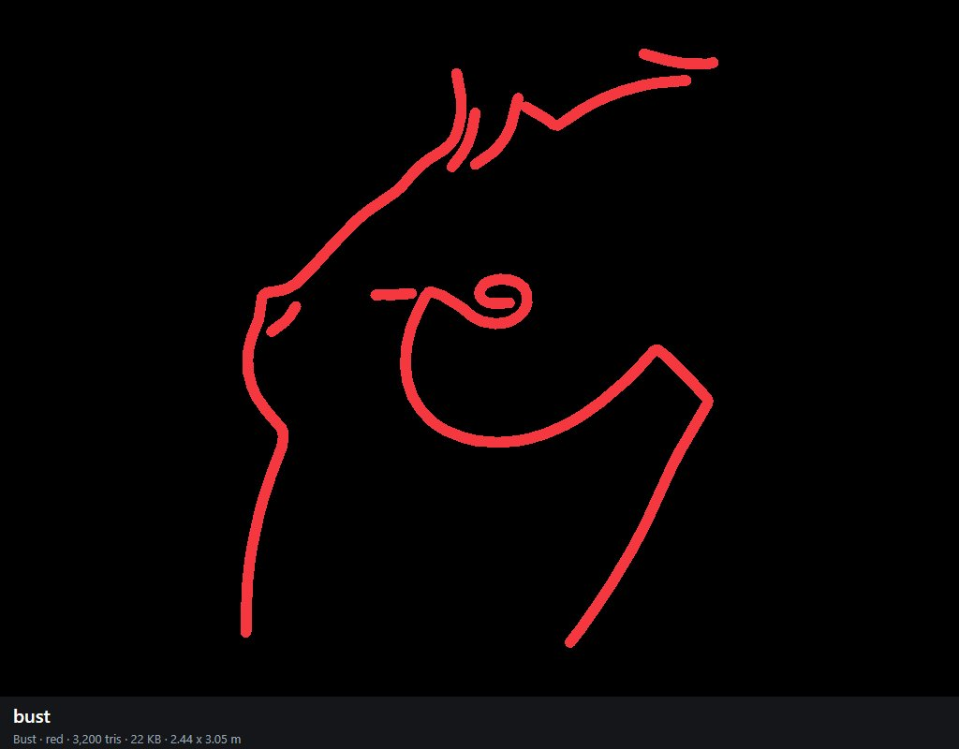

lounging (Lounging)
pink; 4,448 triangles; 30 KB; 3.06 x 1.09 m as built (the shop scales it to its wall). Photo: more Neon sexy / il_300x300.6460533399_fww6.jpg.
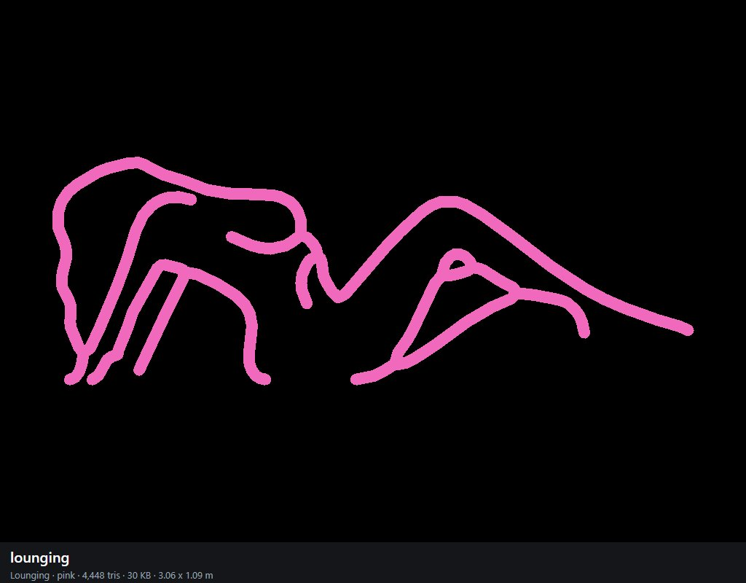

hug-knees (Knees)
blue, cyan, magenta, pink, purple, red; 7,648 triangles; 55 KB; 3.05 x 2.93 m as built (the shop scales it to its wall). Photo: more Neon sexy / il_300x300.7519725935_mkje.webp.
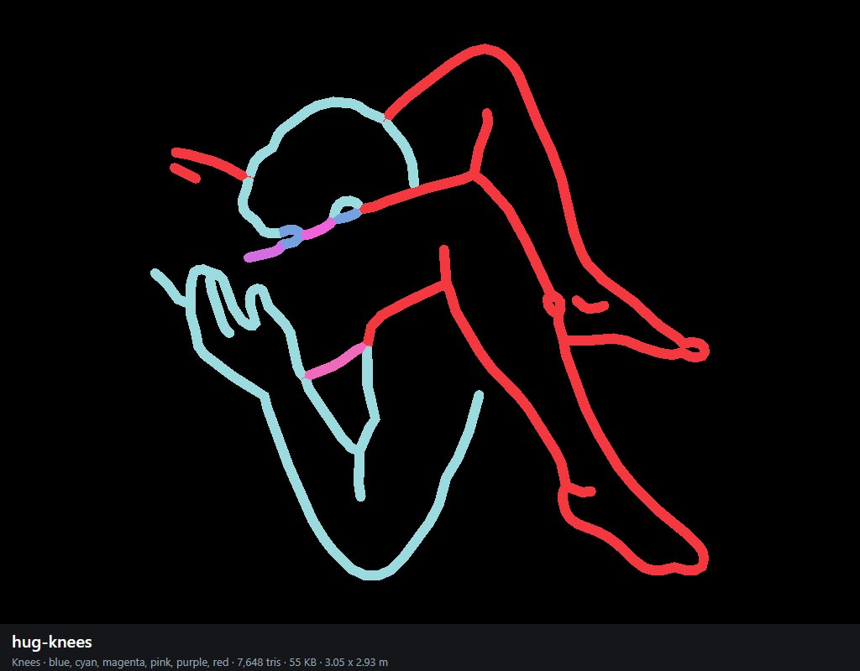

embrace (Embrace)
magenta, pink, purple; 8,624 triangles; 58 KB; 1.47 x 3.06 m as built (the shop scales it to its wall). Photo: more Neon sexy / il_300x300.7947440500_dbhu.avif.
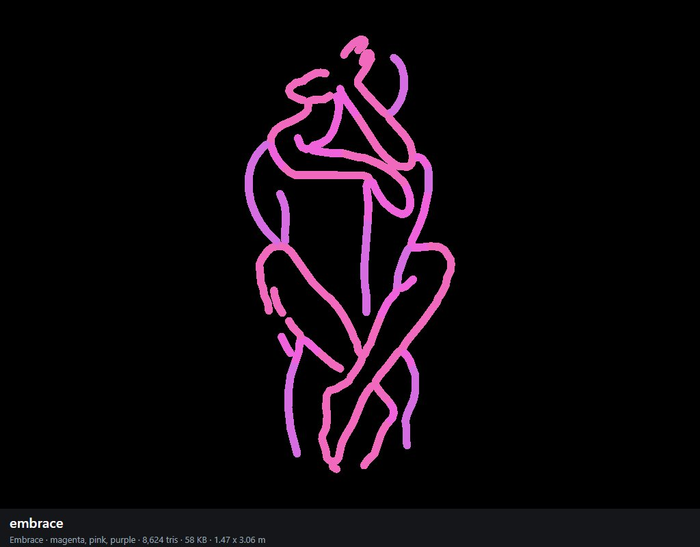

angel-wings (Angel wings)
white; 18,144 triangles; 116 KB; 2.92 x 3.06 m as built (the shop scales it to its wall). Photo: more Neon sexy / il_300x300.8011763505_t3uw.webp.
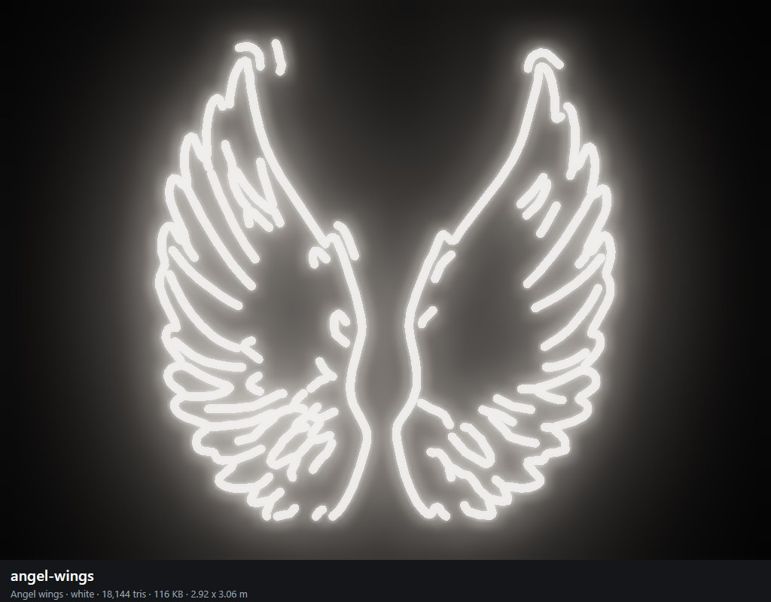

wine-glass-lady (In the glass)
orange, pink, red, yellow; 6,336 triangles; 45 KB; 1.73 x 3.06 m as built (the shop scales it to its wall). Photo: more Neon sexy / il_300x300.8044227614_5lja.webp.
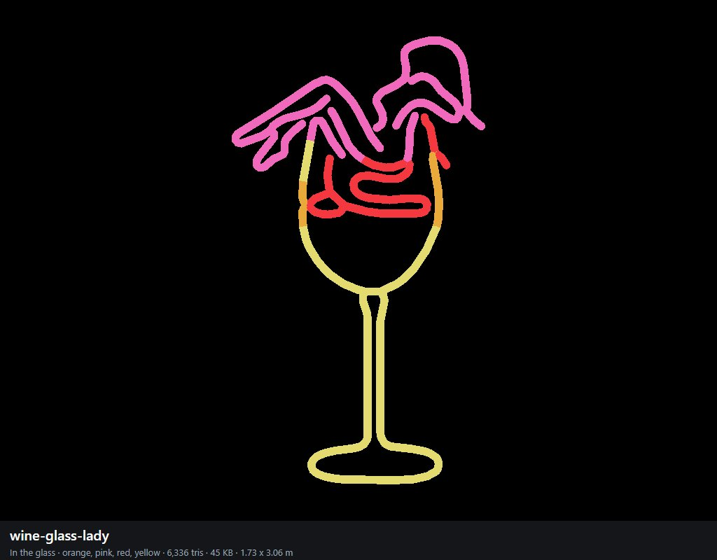

pole-upside (Upside down)
blue, cyan, magenta, pink, purple; 10,992 triangles; 75 KB; 1.76 x 3.06 m as built (the shop scales it to its wall). Photo: more Neon sexy / il_300x300.8312941256_f2s0.avif.
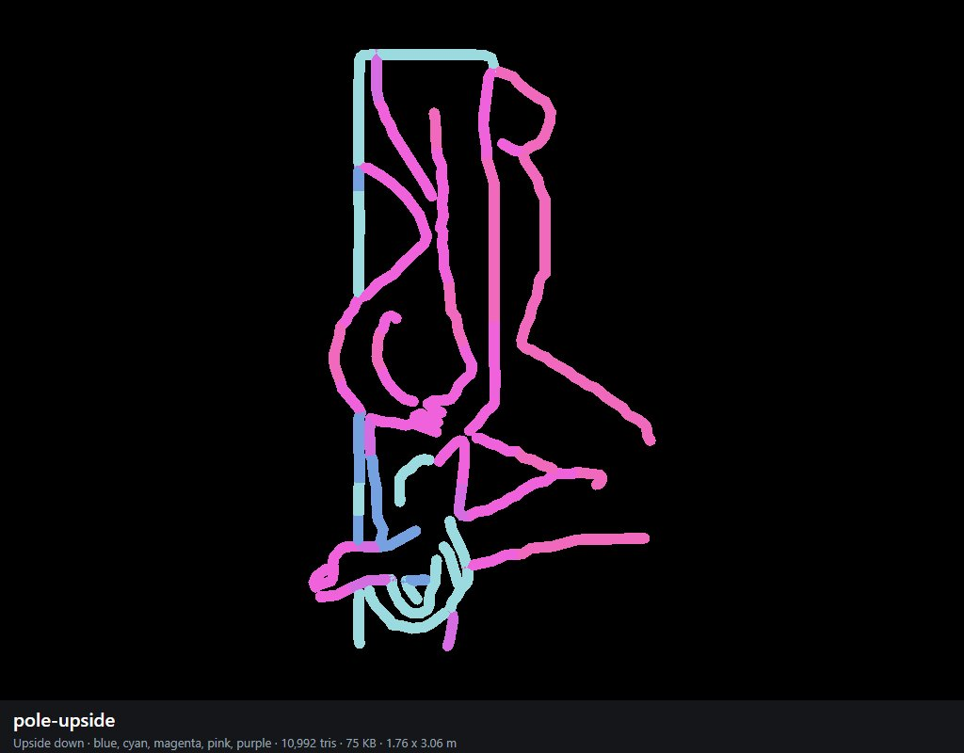

towel (Towel)
magenta, pink, white; 5,120 triangles; 36 KB; 1.73 x 3.06 m as built (the shop scales it to its wall). Photo: more Neon sexy / il_fullxfull.6813833290_tn9q.avif.
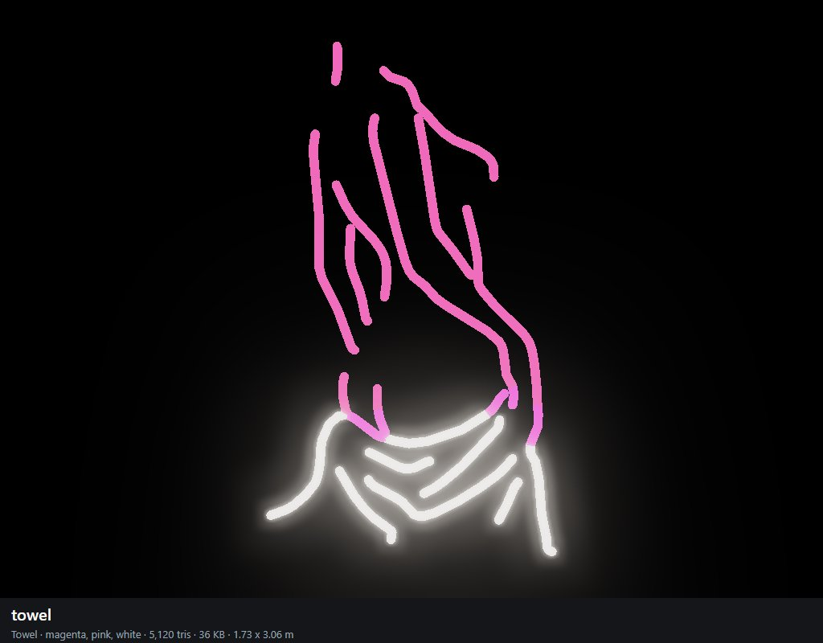

mudflap (Mudflap)
pink; 3,200 triangles; 22 KB; 3.09 x 2.10 m as built (the shop scales it to its wall). Photo: more Neon sexy / images (1).jfif.
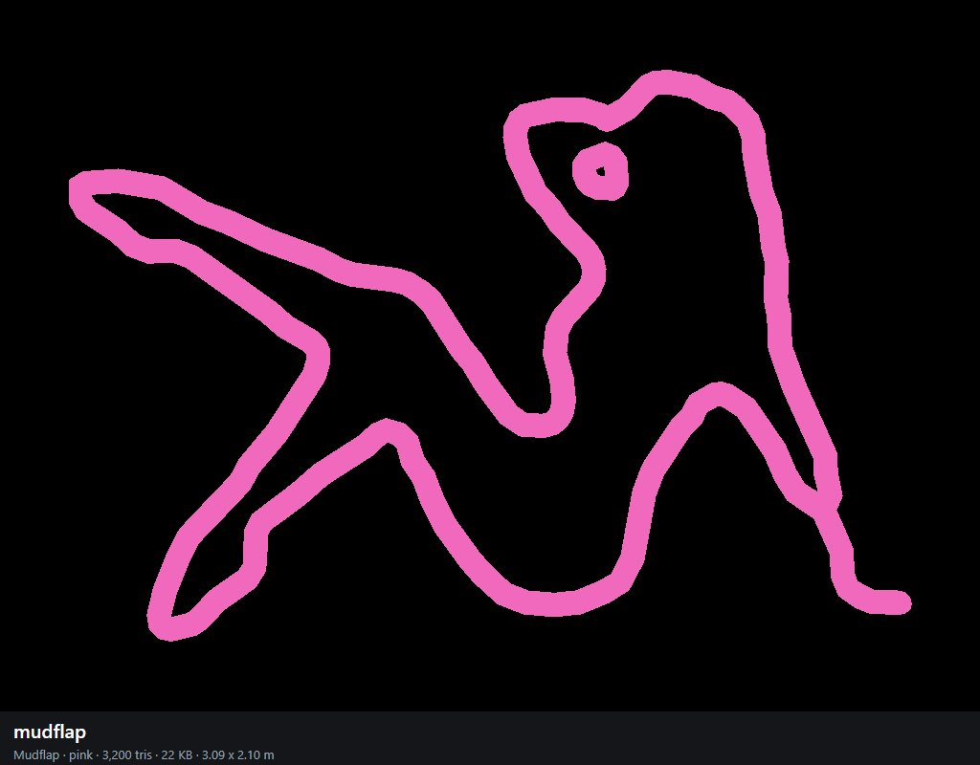

lollipop-lips (Lollipop)
magenta, orange, pink, red, yellow; 5,696 triangles; 42 KB; 2.32 x 3.06 m as built (the shop scales it to its wall). Photo: more Neon sexy / images (10).jfif.
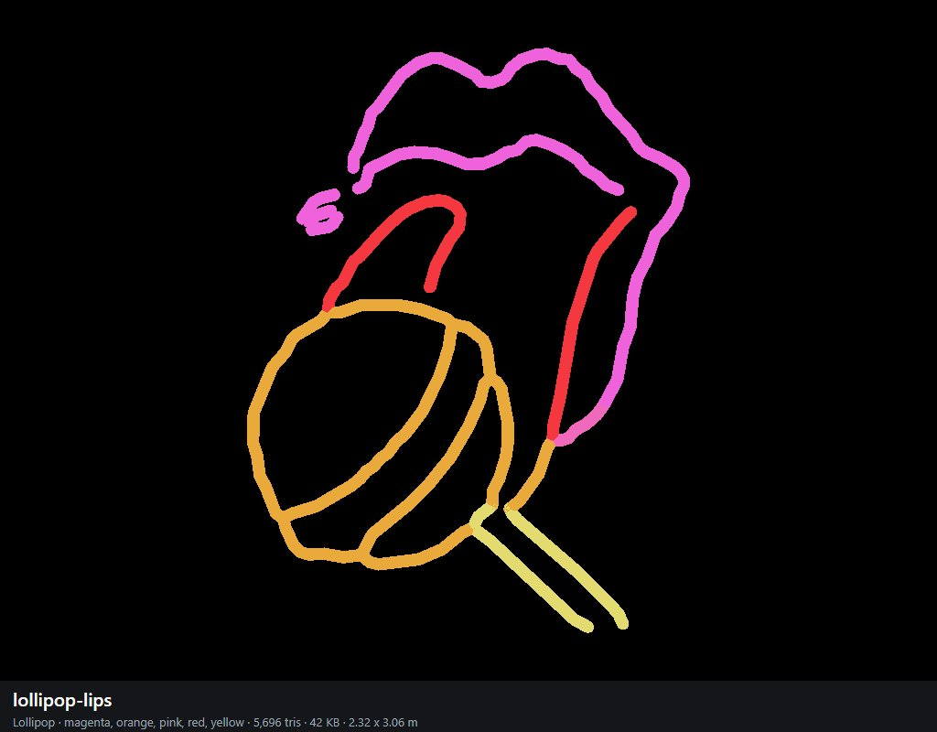

garter-legs (Garters)
blue, pink, purple, red; 8,784 triangles; 61 KB; 3.05 x 1.75 m as built (the shop scales it to its wall). Photo: more Neon sexy / images (11).jfif.
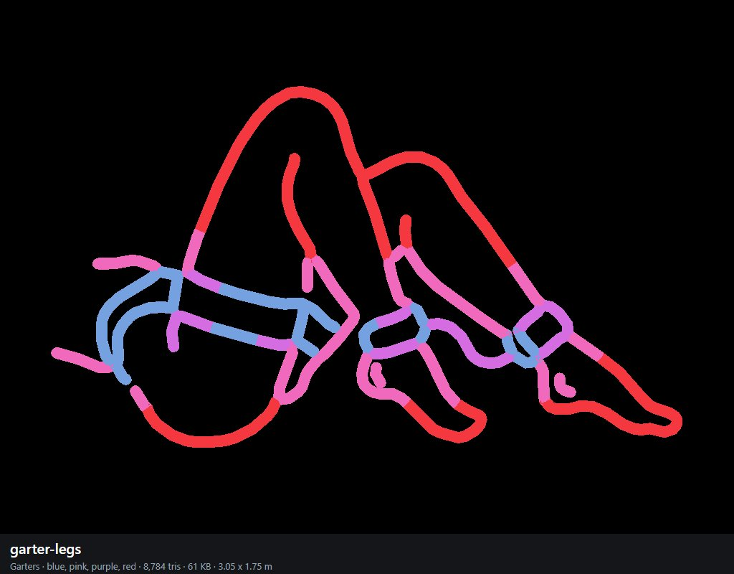

legs-up (Legs up)
pink; 6,144 triangles; 41 KB; 2.87 x 3.07 m as built (the shop scales it to its wall). Photo: more Neon sexy / images (2).jfif.
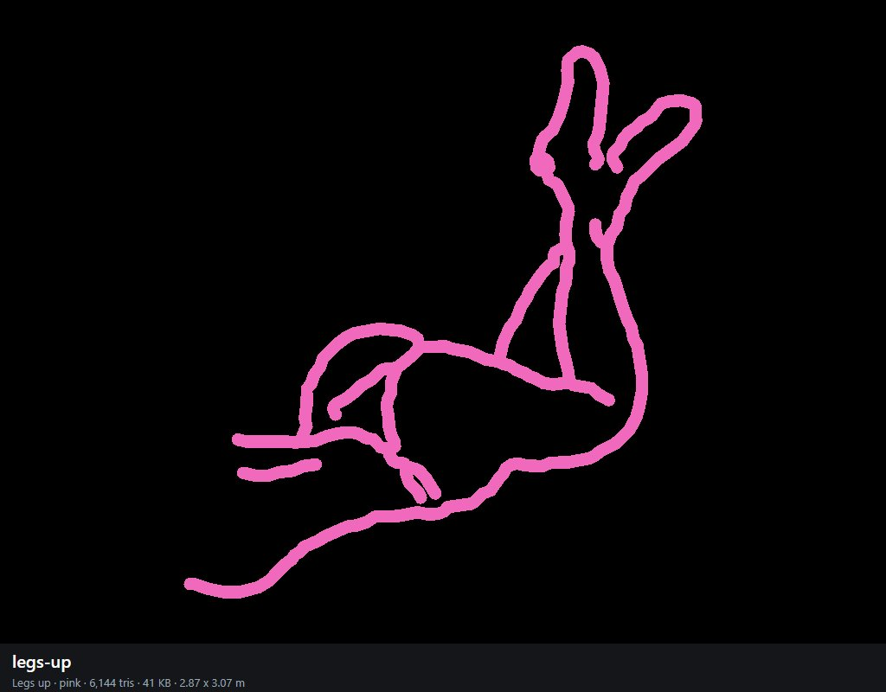

bar-bottle (Bar bottle)
cyan, magenta, orange, pink, red, white, yellow; 10,288 triangles; 72 KB; 3.06 x 1.58 m as built (the shop scales it to its wall). Photo: more Neon sexy / images (3).jfif.
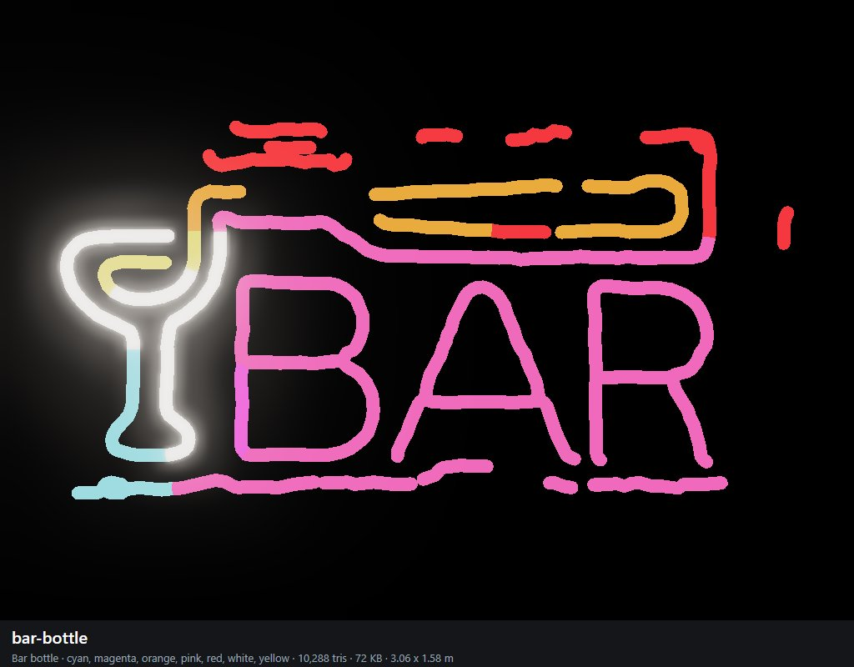

bar-lady (Bar lady)
blue, green, magenta, pink, purple, white; 10,032 triangles; 69 KB; 2.24 x 3.07 m as built (the shop scales it to its wall). Photo: more Neon sexy / images (4).jfif.
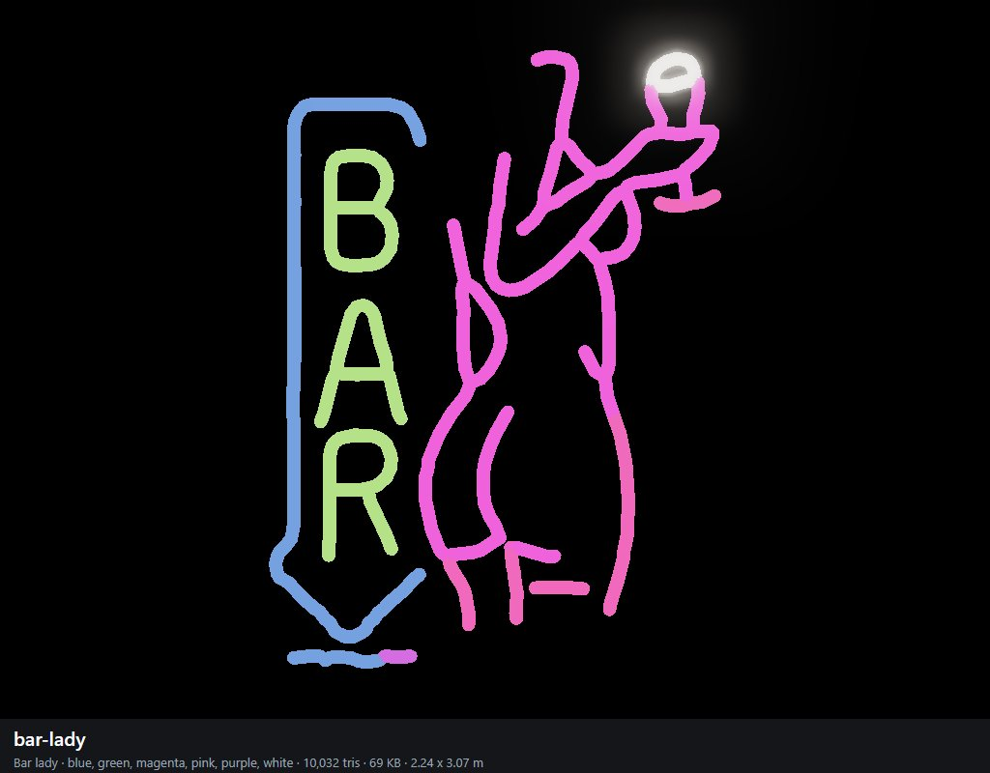

cheers (Cheers)
red; 5,152 triangles; 35 KB; 2.35 x 3.08 m as built (the shop scales it to its wall). Photo: more Neon sexy / images (5).jfif.
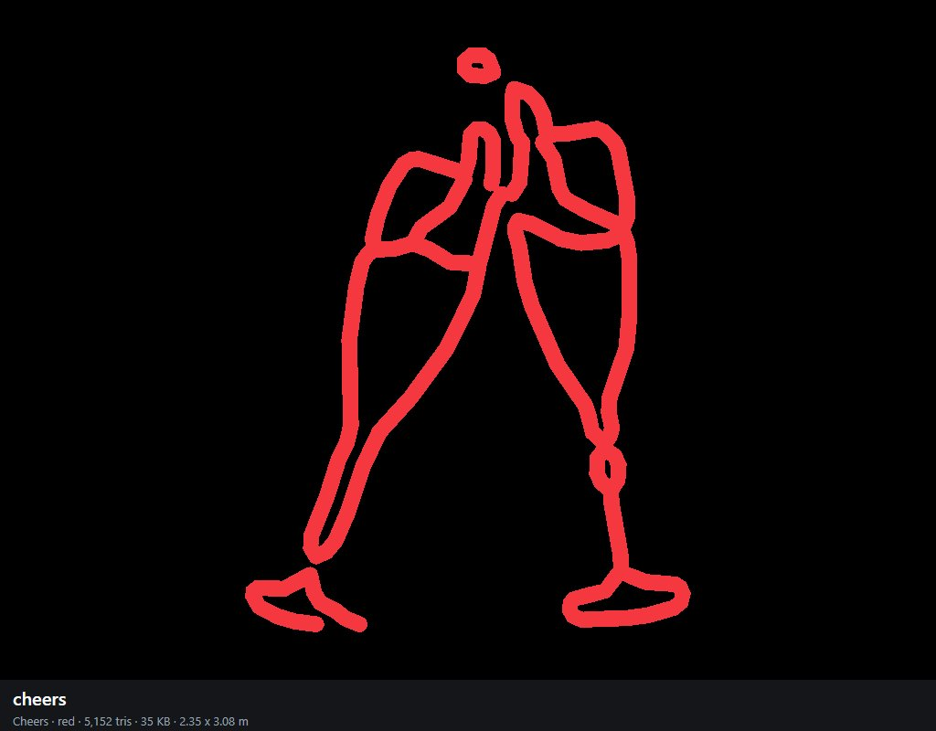

cocktail (Cocktail)
orange, white, yellow; 6,464 triangles; 44 KB; 2.36 x 3.07 m as built (the shop scales it to its wall). Photo: more Neon sexy / images (6).jfif.
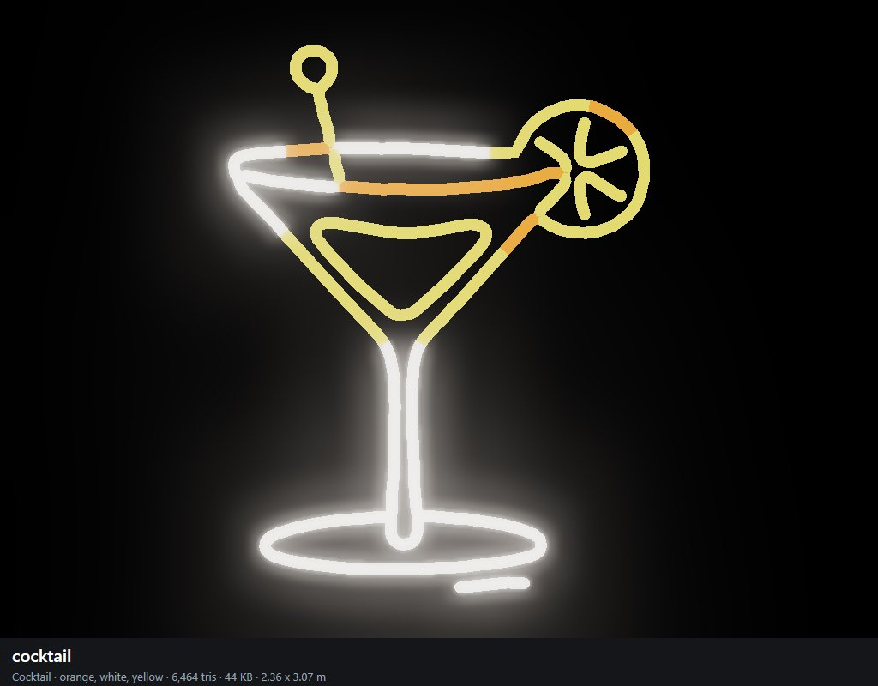

moon-girl (Moon girl)
magenta, pink; 8,304 triangles; 55 KB; 1.47 x 3.06 m as built (the shop scales it to its wall). Photo: more Neon sexy / images (7).jfif.
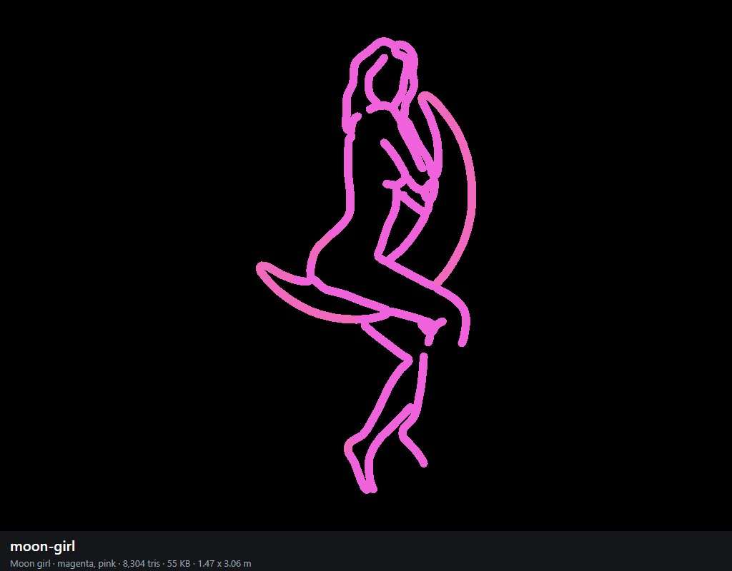

relax (Relax)
cyan, green; 7,568 triangles; 50 KB; 3.06 x 1.26 m as built (the shop scales it to its wall). Photo: more Neon sexy / images (9).jfif.
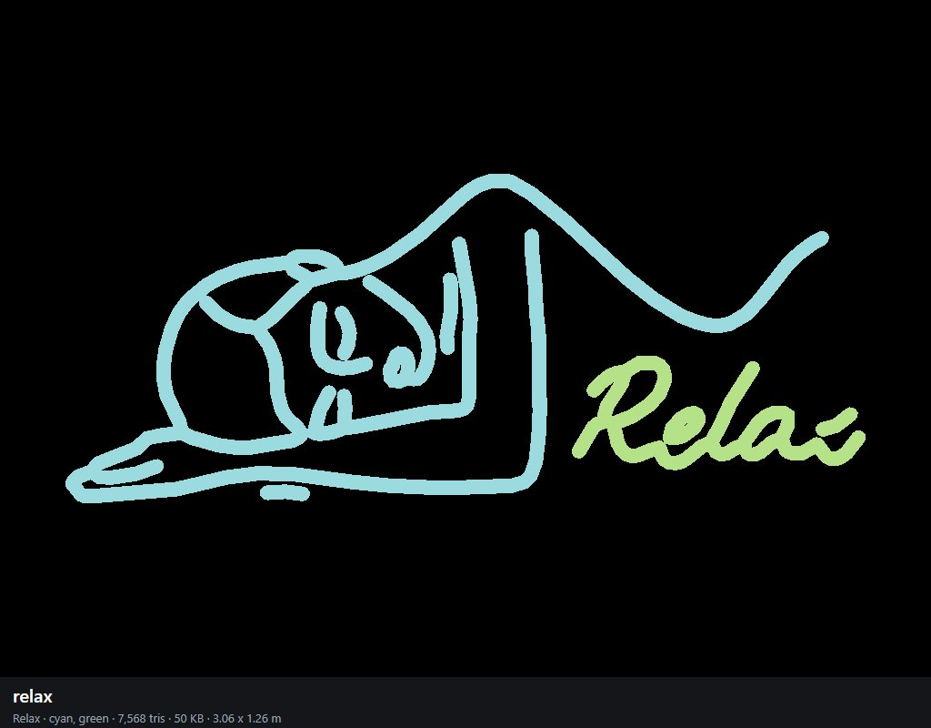

curvy-silhouette (Curvy)
magenta; 4,400 triangles; 29 KB; 1.32 x 3.06 m as built (the shop scales it to its wall). Photo: more Neon sexy / images.jfif.
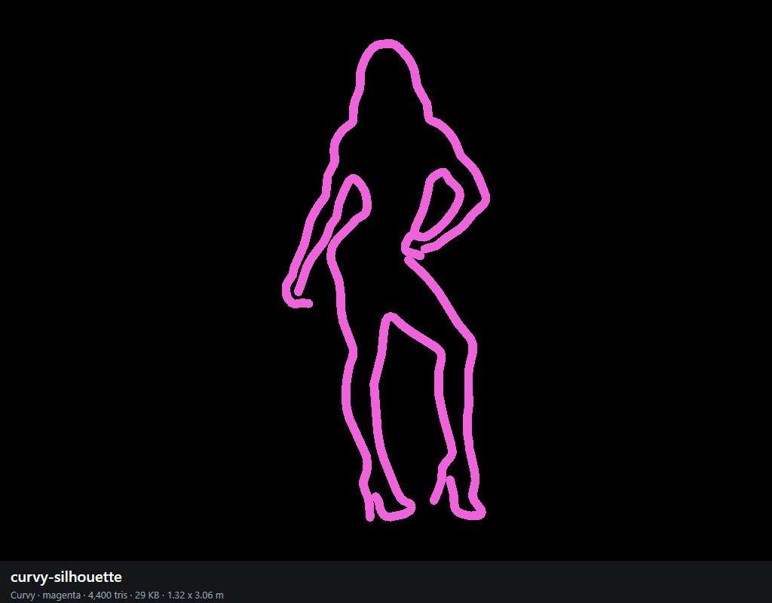

bikini-girl (Bikini girl)
blue, cyan, magenta, pink, red, white; 15,440 triangles; 104 KB; 2.11 x 3.06 m as built (the shop scales it to its wall). Photo: more Neon sexy / jessica-bunny-neon-led-schild.webp.
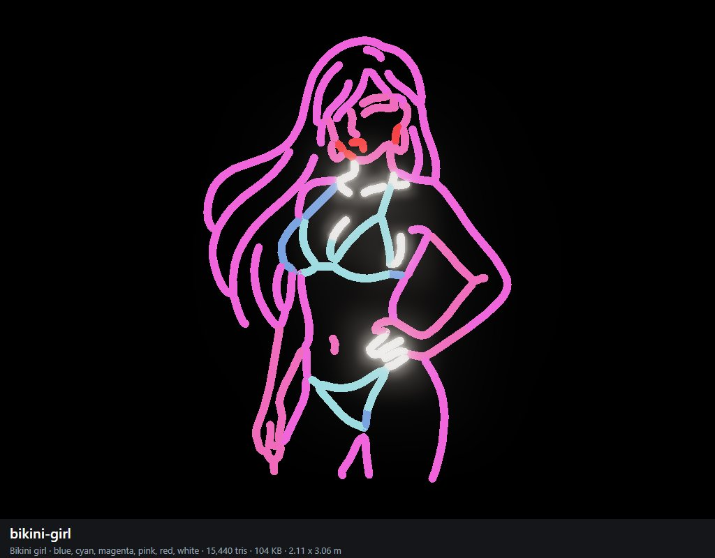

kiss-me (Kiss me)
cyan, orange, pink, red, white, yellow; 6,864 triangles; 51 KB; 2.68 x 3.06 m as built (the shop scales it to its wall). Photo: more Neon sexy / kiss-me-neon-sign-pink_1000x.webp.
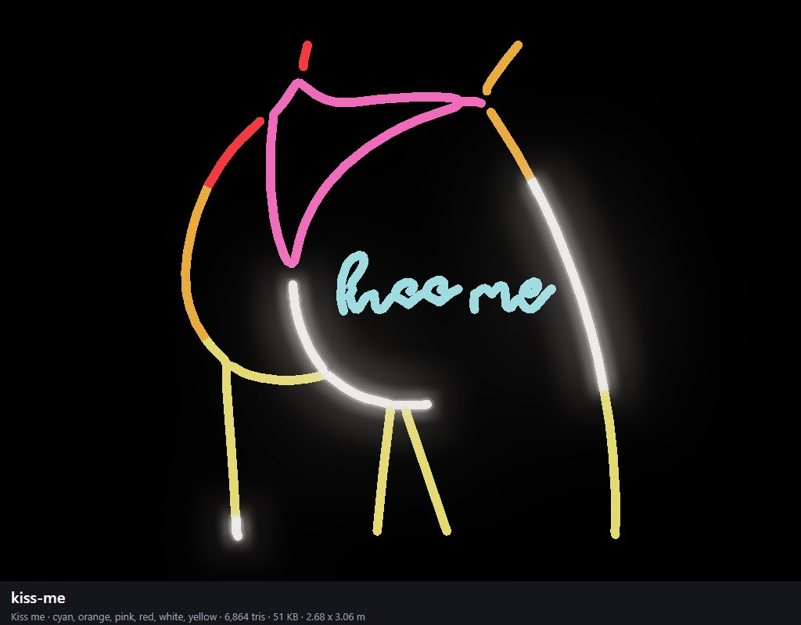

sexy (Sexy)
magenta; 7,472 triangles; 48 KB; 2.80 x 3.07 m as built (the shop scales it to its wall). Photo: more Neon sexy / neon-sign-bright-colors-girls-260nw-1333214828.webp.
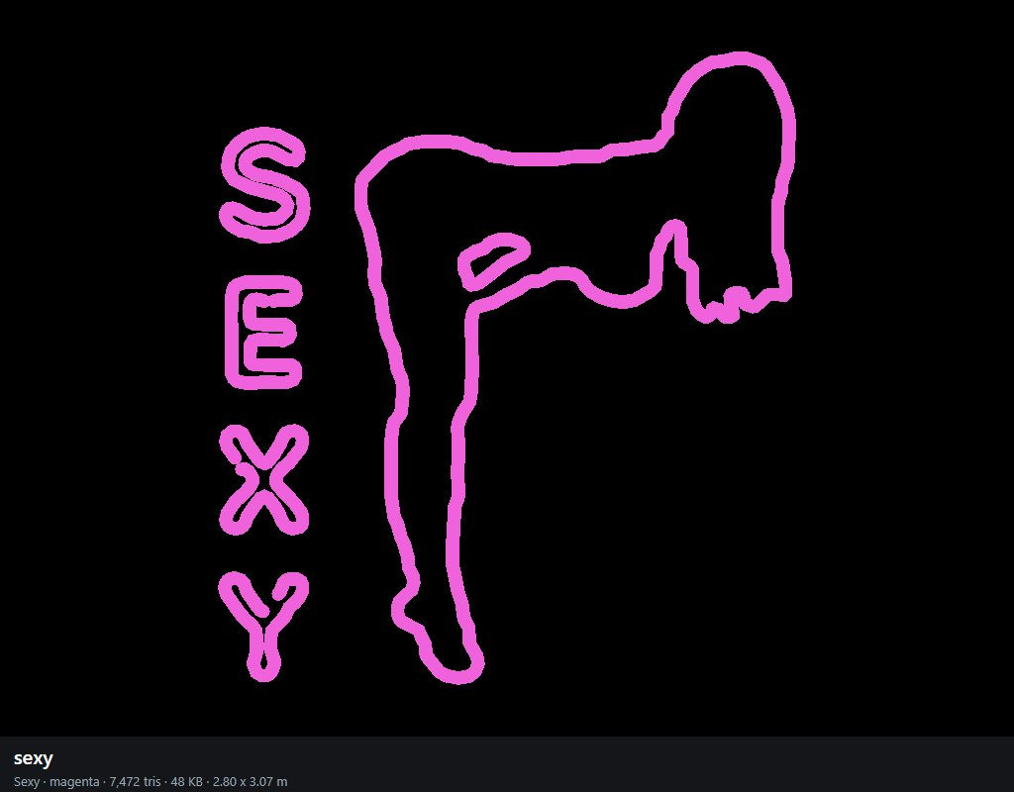

legs-gold (Gold legs)
yellow; 3,936 triangles; 27 KB; 2.84 x 3.09 m as built (the shop scales it to its wall). Photo: more Neon sexy / neon-sign-showing-woman-legs-in-sexy-pose-on-black-background-vector.jpg.
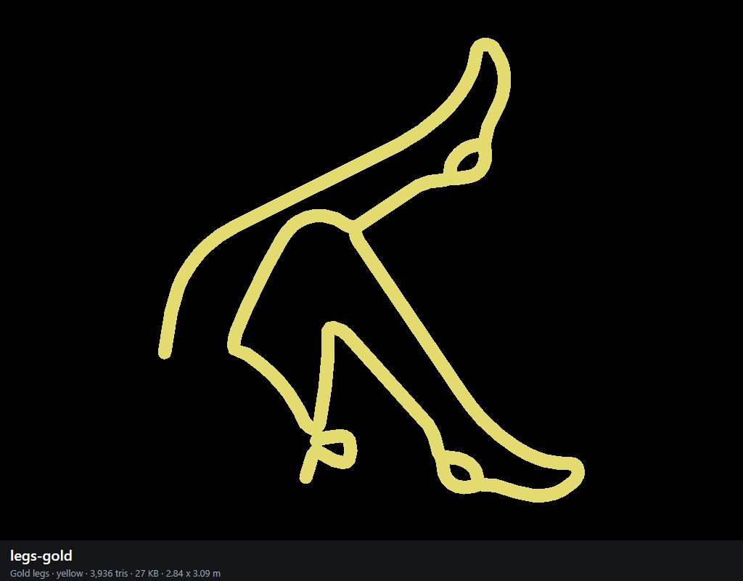

legs-red (Red legs)
red; 2,800 triangles; 19 KB; 3.06 x 1.75 m as built (the shop scales it to its wall). Photo: more Neon sexy / night-club-led-led-neon-light-line-women-leg-led-neon-lamp-sexy-aesthetic-png.webp.
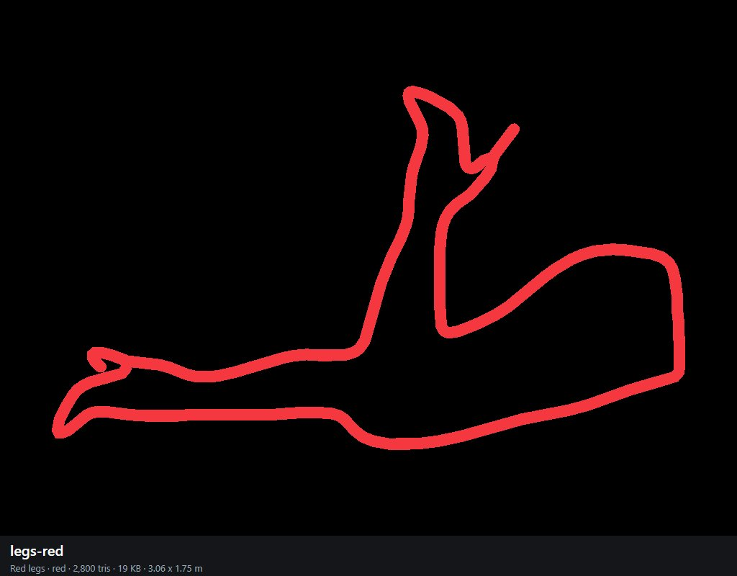

bum-outline (Outline)
magenta; 2,448 triangles; 17 KB; 1.95 x 3.06 m as built (the shop scales it to its wall). Photo: more Neon sexy / nude-neon-lamp.jpg.
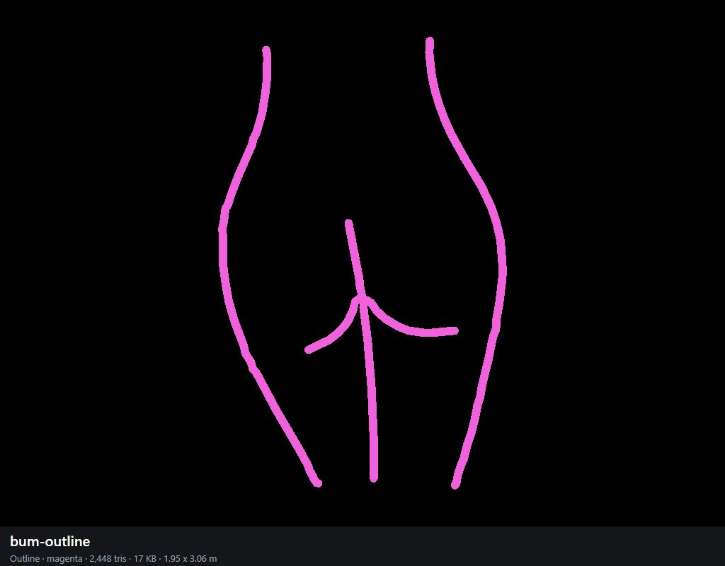

pole-girl (Pole girl)
blue, cyan, magenta, pink, purple, white; 12,800 triangles; 87 KB; 1.66 x 3.06 m as built (the shop scales it to its wall). Photo: more Neon sexy / s-l1200.png.
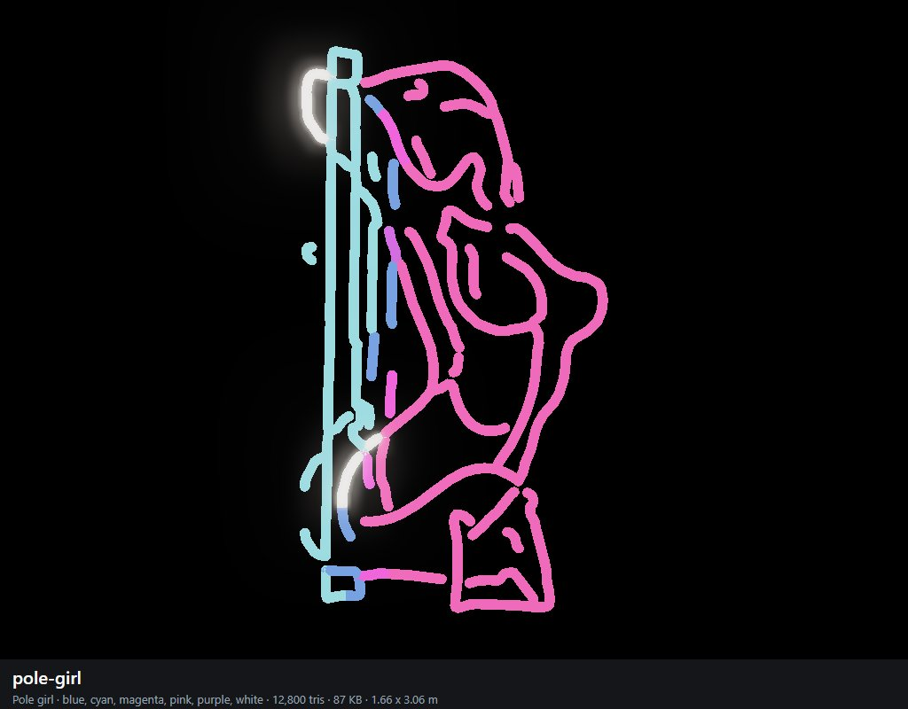

anime-heart (Manga heart)
blue, cyan, purple, white; 20,000 triangles; 131 KB; 1.74 x 3.06 m as built (the shop scales it to its wall). Photo: more Neon sexy / sarah-love-bunny-neon-led-schild.webp.
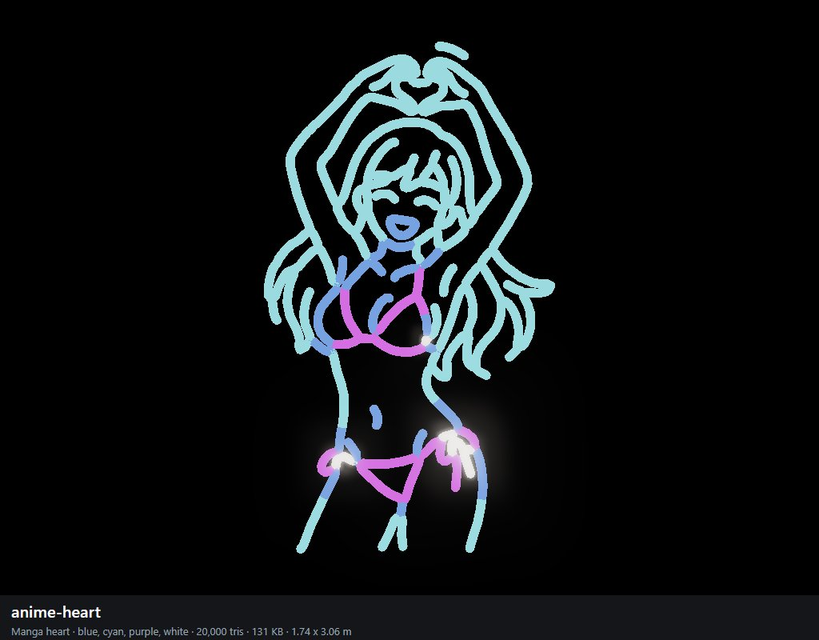

bikini-standing (Pink bikini)
orange, pink, red; 7,920 triangles; 53 KB; 1.41 x 3.06 m as built (the shop scales it to its wall). Photo: more Neon sexy / siluette-neon-led-schild.webp.
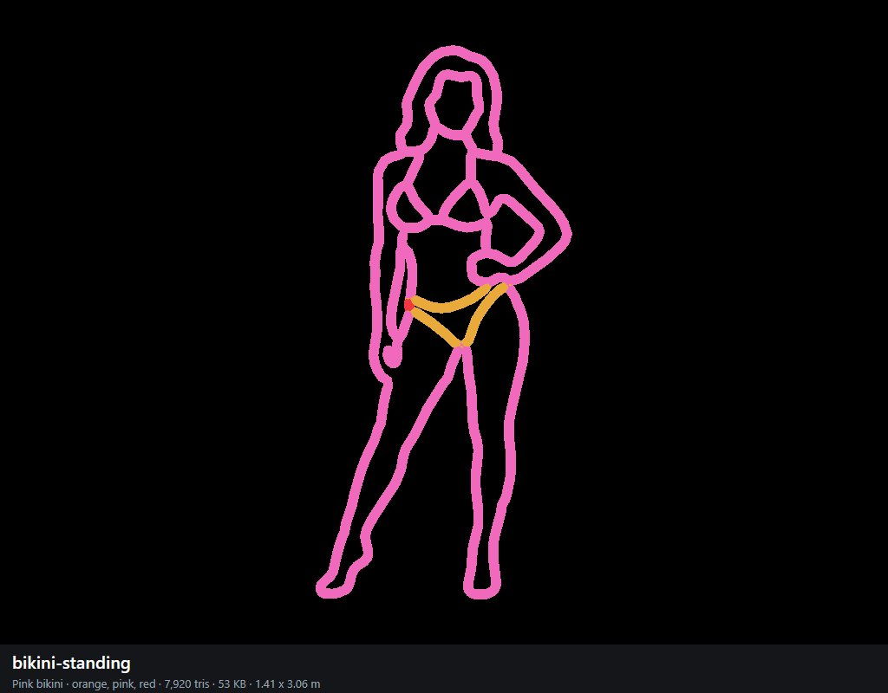

anime-sitting (Manga sitting)
purple, white; 17,376 triangles; 112 KB; 2.57 x 3.06 m as built (the shop scales it to its wall). Photo: more Neon sexy / tanja-bunny-neon-led-schild.webp.
